

GP Patient Survey 2025

Technical annex

GPPS Y19 | Version 1 | PUBLIC | This work was carried out in accordance with the requirements of the international quality standard for Market Research, ISO 20252 © Ipsos 2025
Contents
1 Introduction 7
1.1 Survey governance 7
2 Questionnaire and material design 10
2.1 Questionnaire development for the 2025 survey 10
2.2 Online only questions 12
2.3 The final questionnaire 15
2.4 Materials development for the 2025 survey 16
2.5 Cognitive testing: questionnaire and materials 16
3 Sampling 18
3.1 Sample overview 18
3.2 NHS England population extraction procedure 18
3.3 Patients eligible for the survey 18
3.4 Practices included in the survey 18
3.5 Sample size calculation 19
3.6 Adjustments to response rate estimates 19
3.7 Patient sample selection 19
3.8 Personal data extractions 20
3.9 Sample cleaning and exclusions 20
3.10 Final mailed sample after cleaning and exclusions 21
3.11 Movers checks 21
4 Communications with patients and practices 23
4.1 Survey website 23
4.2 Support for participants 25
5 Data collection 29
5.1 Contact strategy 29
5.2 Mailing process 30
5.3 Text messages 30
5.4 Handling reminders 31
5.5 Online completion 31
5.6 Telephone completion 38
5.7 Braille and large print versions 38
5.8 Respondent burden 38
6 Data analysis 40
6.1 Questionnaire processing 40
6.2 Inclusions and exclusions 40
6.3 Quality assurance 41
6.4 Editing the data 41
6.5 Weighting strategy 43
6.6 Unweighted and weighted respondent profiles 45
6.7 Confidence intervals 48
7 Response rates 51
7.1 Unadjusted response rates (published) 51
7.2 Adjustments to response rate 54
8 Reporting 57
8.1 Official statistics status of GPPS results 57
8.2 Presentation of results 57
8.3 Calculation of results and percentages 57
8.4 Trend data 59
8.5 Suppression 60
8.6 Weighting 61
8.7 Organisation mapping 61
8.8 Changes to reporting outputs 62
8.9 Deliverables 62
8.10 The GPPS ‘Surveys and Reports’ page 65
8.11 The GPPS analysis tool 67
8.12 Practice comparison tool 69
9 Data quality statement 72
9.1 Purpose 72
9.2 Relevance 72
9.3 Accuracy and reliability 72
9.4 Timeliness and punctuality 74
9.5 Accessibility and clarity 74
9.6 Coherence and comparability 74
9.7 Trade-offs between output quality components 75
10 Appendix 77
10.1 Survey materials 77
10.2 Experiments 77
10.3 Allocation of sample to treatment groups 78
10.4 Results 78

List of figures
Figure 4.1: The www.gp-patient.co.uk homepage 23
Figure 5.1: Login screen for online survey 32
Figure 5.2: Question from the online survey 33
Figure 5.3: Introduction page for SMS route to online survey with language selection option 35
Figure 7.1: Number of practices within each response rate band over time 52
Figure 7.2: National response rates to the survey over time 53
Figure 8.1: Survey and reports page on the GPPS website 65
Figure 8.2: ICS slide packs page 66
Figure 8.3: PCN dashboard 67
Figure 8.4: Website analysis tool – Trends 2024 and 2025 69

List of tables
Table 5.1: Survey mailout and SMS reminder dates 30
Table 5.2: Number and proportion of online returns 34
Table 5.3: Completes per language and BSL 37
Table 6.1: Confidence interval examples for practices, PCNs, ICSs and national data 48
Table 6.2: Power calculations for PCNs, ICSs and practices 49
Table 7.1: Surveys sent, returned and response rates 51
Table 7.2: Response rates for female and male 51
Table 7.3: Response rates by age 51
Table 7.4: Number and proportion of practices within each response rate band 52
Table 7.5: Unweighted, weighted and adjusted response rates 55
Table 8.1: List of quasi-identifiable questions 60
Table 8.2: Reports (published via the www.gp-patient.co.uk website) 62
Table 8.3: Weighted and unweighted datasets provided to NHS England (not published) 64
Table 8.4: Technical documents (published via the website) 64

1
Introduction
- Introduction
This technical annex provides details of the 2025 GP Patient Survey (GPPS) conducted by Ipsos. The survey was undertaken on behalf of NHS England.
This is the nineteenth year that the GPPS has been conducted in England. Between 2011 and 2016 the survey took place twice a year, having previously been conducted on a quarterly basis (April 2009 - March 2011) and annually (January 2007 - March 2009). In 2017, the survey returned to an annual format.
Patients are randomly selected from all GP practices in England, using the Personal Demographics Service (PDS). In total, 2.72 million patients aged 16 or over were invited to take part. The survey uses an ‘online first’ approach, using a sequential push-to-web methodology which only offers a paper questionnaire in the final mailing. In January 2025, paper letters invited patients to take part in the survey online. This was followed by a combination of SMS and e-letter reminders (to those with a valid mobile phone number and paper reminders to others). A final paper reminder, including a copy of the questionnaire, was sent out six weeks after the initial mailing to those who had not yet taken part online. During fieldwork the decision was taken to add an extra SMS to the contact strategy to help boost response rates. The complete contact strategy and fieldwork dates are reported in Chapter 5: Data collection.
The 2024 survey was the start of a new time series for GPPS. It was therefore important that questionnaire changes were kept to a minimum for the 2025 survey to ensure that results could be compared across 2024 and 2025. However, as in every year, the questionnaire content was reviewed to ensure it reflects the primary care context and priorities. This led to some very minor changes. In addition to the core (online and paper) questionnaire, a small number of additional questions were added to the online version of the survey. More information on the questionnaire design process is available in Chapter 2: Questionnaire and material design.
Ipsos and NHS England have also trialled several experiments on a sub-sample of survey respondents this year. These experiments tested contacting people in different ways including replacing the final paper mailing with an e-letter as well as using email and branded messaging to improve data quality and save costs.
Copies of the questionnaire and materials sent in 2025 are available on the website.
  - Survey governance
Since February 2014, the governance of the survey has involved input from a steering group, which meets regularly to provide a forum in which GPPS stakeholders can be kept informed of survey progress. The group provide advice to the research team and debate key issues such as questionnaire content, changes to the sampling strategy and analysis and reporting; review the findings of the survey as they emerge; consider the need for any further research and analysis; and raise any questions about GPPS with NHS England and Ipsos.
In addition to NHS England and Ipsos, the group consists of representatives from a range of stakeholders, including the following:
  - Academics.
  - British Medical Association.
  - Care Quality Commission.
  - Integrated Care Systems (ICS) representatives.
  - Department of Health and Social Care.
  - Healthwatch England.
  - GP membership.
  - Patient Participation Group (PPG) representative.
  - Patient representatives.
  - Health and social care charities representative.
  - Primary Care Network (PCN) professional representative.
  - Royal College of General Practitioners.
  - National Voices.

2
Questionnaire and material design

- Questionnaire and material design
  - Questionnaire development for the 2025 survey
The 2024 survey was the start of a new time series for GPPS (see the Technical Annex for the 2024 survey). It was therefore important that questionnaire changes were kept to a minimum for the 2025 survey to ensure that results could be compared across 2024 and 2025.
However, as in every year, the questionnaire content was reviewed to ensure it reflects the primary care context and priorities. This led to minor changes to the wording of some of the response options for two questions, which has impacted trends. These changes have affected the comparability of these questions, even though the question wording remains the same. This is because it is difficult to determine whether a difference in results is caused by the change to the response options or a ‘real difference’.
Changes were made to the following questions:
Q9 'On that occasion, what was your main reason for trying to contact your GP practice?'
- The 2024 response option ‘Ask for help with an administrative request (for example, getting a fit note or updating contact details)’ was split into two new responses (‘Make an administrative request (for example, updating contact details or personal information)’ and ‘Get help with a fit note or any other medical evidence (for example, for benefit claims or background medical checks)’. This was designed to capture differences between tasks which could be completed by practice staff and those which need a GP or other healthcare professional.
- The 2024 response options ‘Get advice or treatment from a healthcare professional for a new health issue’ and ‘Get advice or treatment from a healthcare professional for an existing health issue’ had the words ‘new’ and ‘existing’ changed to bold to help differentiate between them.
- Due to a high level of multi-coding on the paper questionnaire, for this single code question, the instruction (‘If more than one of these applies to you, please put an ✗ in the box next to the main one only’), was shortened to ‘Please put an ✗ next to the main one only’ to make this clearer.
- As a result of these changes, trend data is not presented for this question.

2024 question wording | 2025 question wording
Q9 On that occasion, what was your main reason for trying to contact your GP practice?  If more than one of these applies to you, please put an ✗ in the box next to the main one only.  - Get advice or treatment from a healthcare professional for a new health issue  - Get advice or treatment from a healthcare professional for an existing health issue  - Get a prescription  - Get test results  - Ask for help with an administrative request (for example, getting a fit note or updating contact details)  - Discuss a referral for specialist care  - Register with the practice as a new patient  - Do something else | Q9 On that occasion, what was your main reason for trying to contact your GP practice?  Please put an ✗ next to the main one only.  - Get advice or treatment from a healthcare professional for a new health issue  - Get advice or treatment from a healthcare professional for an existing health issue  - Get a prescription  - Get test results  - Make an administrative request (for example, updating contact details or personal information)  - Get help with a fit note or any other medical evidence (for example, for benefit claims or background medical checks)  - Discuss a referral for specialist care  - Register with the practice as a new patient  - Do something else

Q39 'Which of the following long-term conditions or illnesses do you have?'
- The 2024 response option ‘Joint problem, such as arthritis’ was changed to ‘Arthritis or problem with your back or joints’ in 2025. This was to better capture the full range of musculoskeletal conditions, including back pain, which contributes most to disability adjusted life year measurements and is one of the commonest causes of loss of work. This response option was also moved to the top of the list of response options, due to the list being organised in alphabetical order.
- Following data analysis, trends are not presented for 'Arthritis or problem with your back or joints' and the 2024 response option ('Joint problem, such as arthritis') as these are not directly comparable.

2024 question wording | 2025 question wording
Q39 Which of the following long-term conditions or illnesses do you have?  Please put an ✗ in all the boxes that apply.  - Autism or autism spectrum condition  - Blindness or partial sight  - Cancer in the last five years  - Deafness or hearing loss  - Dementia or Alzheimer’s disease  - Diabetes  - Heart or cardiovascular condition  - High blood pressure  - Joint problem, such as arthritis  - Kidney or liver disease  - Learning disability  - Lung or breathing condition  - Mental health condition  - Neurological condition  - Stroke or TIA (Transient Ischemic Attack)  - Another long-term condition or illness  - I don’t have any long-term conditions | Q39 Which of the following long-term conditions or illnesses do you have?  Please put an ✗ in all the boxes that apply.  - Arthritis or problem with your back or joints  - Autism or autism spectrum condition  - Blindness or partial sight  - Cancer in the last five years  - Deafness or hearing loss  - Dementia or Alzheimer’s disease  - Diabetes  - Heart or cardiovascular condition  - High blood pressure  - Kidney or liver disease  - Learning disability  - Lung or breathing condition  - Mental health condition  - Neurological condition  - Stroke or TIA (Transient Ischemic Attack)  - Another long-term condition or illness  - I don’t have any long-term conditions

In addition to these changes, the colour of the routing arrows and instructions on the paper questionnaire were changed from blue to black font to help with navigation.
  - Online only questions
In addition to the core (online and paper) questionnaire, a small number of additional questions were added to the online version of the survey. These included:
- Vaping behaviour (added to the online survey in 2024, and remained in the 2025 survey).
- Questions on the NHS Accessible Information Standard (new for the 2025 survey).
- Permission for recontact (new for the 2025 survey). General recontact permission for NHS England to find out more about specific healthcare experiences and permission for ONS to recontact carers.
It was not possible to include these questions in the paper questionnaire due to space constraints. However, given the nature of the questions, anyone requesting an accessible version of the paper questionnaire (large print or Braille) was also sent these questions (including the general recontact question only). They were also asked of anyone taking part with Helpline support.
Vaping
Q64 Which of the following best describes your vaping habits?
- Never vaped
- Former vaper
- Occasional vaper
- Regular vaper
Accessible Information Standard
The next few questions are about communication and getting information from healthcare professionals in a way you can understand.
For example, you may need help if you are:
- A person with a learning disability
- Deaf
- Blind, or
- Have hearing or sight loss
Q65 Do you find it difficult to see, hear, speak, read or understand what is being said to you?
- Yes
- No
- I don’t know
- I would prefer not to say
Q66 Have you been asked by someone who works at your practice about how you prefer to be given information or communicate?
For example, you may need information in a different format, such as the following:

 |  | 
Easy read | Audio | British Sign Language
 |  | 
Large print | Braille | Letter, email or text

- Yes
- No
- I can’t remember
Q67 Did your GP or practice make a record in your medical notes of how you want to be given information or communicate?
- Yes
- No
- I don’t know
Q68 How often do you get the help you want from staff at your GP practice to communicate and understand the information you are given?
- Always or almost always
- A lot of the time
- Sometimes
- Never or almost never
- I can’t remember
Recontact (carers only)
Thank you for taking part in this survey. Your feedback will help improve GP practices and local health services.

Earlier in the survey you said that you look after, help or support someone because they have a long-term physical or mental health condition or illness, or problems related to old age.

The Office for National Statistics (ONS) are doing some research about carers and may want to speak to you about your experiences.

If you say ‘yes’, we will share your name and contact details (mobile number and email address) with the ONS so that they can contact you to tell you what this research is about and what taking part involves. Agreeing to be contacted does not mean you have to take part.

Do you give your permission for the ONS to contact you in the next two years?

- Yes, I am happy to be contacted by the Office for National Statistics about this research
- No, I would not like to be contacted by the Office for National Statistics about this research

Recontact (asked to all – including carers)
Thank you for taking part in this survey. Your feedback will help improve GP practices and local health services.

NHS England may want to contact people who have taken part in this survey to find out more about their specific healthcare experiences. For example, they may want to speak to unpaid carers, people who had an online GP practice appointment or people who couldn’t get an NHS dental appointment.

If you say ‘yes’, you agree to be contacted about follow-up surveys or research to help improve health and care services. NHS England, or an organisation working on their behalf, will contact you to tell you what this research is about and what taking part involves. Agreeing to be contacted does not mean you have to take part.

If you say ‘no’, you will not be contacted about any follow-up research to this survey. We will delete your contact details and NHS number in line with our privacy policy. For more information, please visit www.gp-patient.co.uk/confidentiality.

Do you give your permission for NHS England to contact you in the next two years to tell you about other surveys or research, based on your answers to this survey?

- Yes, I am happy for my answers to be linked to my contact details and to be contacted in the future
- No, I would not like to be contacted again about any follow-up research to this survey

The inclusion of online-only questions is a new development for GPPS. As such, these results, where published, are labelled as ‘official statistics in development’, in line with the standards in the Code of Practice for Statistics. The trustworthiness, quality and value of these statistics will be evaluated with a view to removing the ‘in development’ label in time. As a result, user feedback on the need for these statistics and how they are being used is important. Please share any feedback on the online-only questions with: GPPatientSurvey@ipsos.com.
  - The final questionnaire
The full questionnaire is available on the website. Chapter 8: Reporting contains more information on interpretation of trend data.
Below is a list of the topics covered in the 2025 questionnaire:
- Your GP practice services
- Your last contact
- Your last appointment
- Overall experience
- When your GP practice is closed
- Your health
- Pharmacy
- Dentistry
- Some questions about you (demographics) (including vaping (online, large print and Braille only))
- Accessible information (online, large print and Braille only)
- Permission for recontact (online, large print and Braille only)
  - Materials development for the 2025 survey
The materials used for the 2025 survey were mostly consistent with those used in 2024. However, some very minor changes were made to improve clarity and consistency, including:
- Changing the wording ‘If you have already taken part, thank you for your time’ to ‘If you have taken part in the last few days, thank you for your time - you do not need to do anything else’. This was based on feedback that the original text implied everyone was sent a reminder regardless of whether they had taken part, and to better communicate potential delays due to printing and postage deadlines.
- The job title for Neil Churchill (the signatory for all letters and SMS) was changed to ‘Director for People and Communities’ to ensure it aligned with the information published online.
- The SMS sender name was changed from GP_Survey to NHS_Survey following changes to the branding rules permitted by the mobile networks.
- SMS messages were amended to include either the recipient’s survey number (to help people who did not want to use the direct link and could not find their letter) or name (to convey legitimacy and allow some duplicate mobile numbers to be included).
In addition, the materials used for the experiments also included some changes, including an additional e-letter and email. More details on the experiment design can be found in the appendices.
It should be noted that during 2025 fieldwork, in order to improve response rates, the decision was made to include an additional SMS after the third SMS reminder.
The full set of letters and SMS wording used are available on the website.
  - Cognitive testing: questionnaire and materials
All proposed changes to the questionnaire and materials made before fieldwork were tested with patients by cognitive interviewing: a method used to critically evaluate the questionnaire and materials and help understand how survey participants process and respond to them. A total of 20 cognitive interviews were conducted over two rounds between 10 and 26 September 2024. Participant feedback was used to ensure that the response options and terminology used in the questionnaire and materials were well understood by a range of patients. The accessible information questions were also reviewed by NHS lived experience partners.
In addition, the questionnaire and materials were reviewed by the Plain English Campaign throughout the cognitive testing process. This ensured the changes met Plain English criteria; a set of principles designed to ensure information is presented clearly. In the context of GPPS this has an additional benefit of reducing barriers to participation for patients with language barriers, literacy issues and learning disabilities. The questionnaire was awarded the Campaign’s Crystal Mark, a seal of approval for the clarity of a document.

3
Sampling

- Sampling

  - Sample overview
The 2025 survey adopted the same sampling approach as the 2024 survey. The sample was designed to ensure that, as far as possible, a minimum of 100 responses per practice and 200 responses per Primary Care Network (PCN) would be received, providing confidence in the overall results and allowing subgroup analysis where appropriate. This resulted in an issued sample size of around 2.72 million patients who were invited to take part.

Patient information was obtained for each practice using registration records held on the Personal Demographics Service (PDS) database maintained by NHS England. The sampling procedure involved two distinct stages. Firstly, NHS England provided an anonymised list of patients for sample size determination and individual patient selection. The selected anonymous records were returned to NHS England, and a second file containing the contact details of the selected patients was provided.
  - NHS England population extraction procedure
As in previous years, NHS England provided a file of pseudonymous patient data for all eligible patients who reside in England or Wales and were registered with a practice in England. The file contained patient NHS numbers, practice code, patient gender, patient age band, and patient postcode.
A sample of patients was then drawn at practice level, as detailed below.
  - Patients eligible for the survey
Patients were eligible for inclusion in the survey if they had a valid NHS number, had been registered with a GP practice continuously for at least six months at the point of selection, and were 16 years of age or over. Note that prior to 2018 the survey had only been open to those aged 18 or over.
  - Practices included in the survey
The list of practices to be included was taken from the NHS England system and comprised all practices that had eligible patients, as defined above, where the practice had not previously opted out of the survey as they felt it was inappropriate to their patient population. The number of practices with eligible patients for the 2025 survey was 6,244, but between sample selection and mail-out, some practices became ineligible for the survey. In total, patients in 6,230 different practices were sent questionnaires, and at least one completed questionnaire was received from patients in 6,215 practices.
  - Sample size calculation
Prior to 2022, the practice sample size was based on aiming for a set confidence interval for each practice. Since 2022, the sample size has been determined to deliver at least 100 responses in each practice and 200 responses in each Primary Care Network (PCN), where possible, and 720,000 responses overall.
The sample design involved a proportionately stratified, unclustered sample, which was drawn for each practice. The sample for each practice is stratified by age, gender, and postcode. The number of patients initially selected for inclusion in the sample for each practice (the ‘issued sample’) was determined by the following components:
- the number of cases required to deliver 100 responses per practice and 200 responses per PCN; and
- the proportion of patients included in the issued sample predicted to respond to the survey.
These components were combined to determine the issued sample size in each practice, PCN and nationally, as follows:
$Issued sample=\frac{Number of responses aimed for at practice | PCN | national level}{Proportion of issued sample predicted to respond at practice | PCN | national level}$
The above figure shows the calculation for the issued sample: the number of responses aimed for at practice, PCN and national level is divided by the proportion of the issued sample predicted to respond.
The proportion of issued sample predicted to respond was estimated using the actual response rate for those practices who took part in the 2024 GPPS and was set at 28% for practices new to the survey or to whom fewer than 100 surveys were issued in the 2024 GPPS. This is to prevent unrealistically high or low response rates being used for new and very small practices.
  - Adjustments to response rate estimates
To prevent issuing very large numbers of questionnaires in practices which had very low response rates in 2024, a minimum response rate of 12.6% was assumed. To ensure that a reasonable number of questionnaires were sent to practices with very high response rates, on the other hand, a maximum assumed response rate of 50.4% was set.
  - Patient sample selection
The pseudonymous patient data sent by NHS England was sorted within each practice by gender, age band and postcode. The required number of patients per practice was selected on a ‘1 in n’ basis, and the unique survey reference numbers returned to NHS England.
  - Personal data extractions
On receipt of the selected records, NHS England extracted the contact details for each of the sampled patients. The extracted file contained, for each patient, their NHS number, patient name, practice code, address, month and year of birth, gender, and mobile number (if available). Where a selected patient had become ineligible since the provision of the anonymous data, an “exclusion” record was sent instead, containing the unique survey serial number and no other details.
  - Sample cleaning and exclusions
Checks were made on the supplied names, mobile numbers and addresses to remove inappropriate records. These checks included:
- duplicates (identified by patient NHS number).
- incorrect mobile numbers (not starting with 07 and/or not 11 digits long).
- non-address details or other inappropriate information contained in the address. This could include:
- key safe numbers, telephone numbers and other numerics not related to the address.
- unexpected words or phrases in the name or address (including “unknown”, “homeless”, “deceased”, “test”, etc.).
- incomplete addresses.
The final selected sample was also checked against the Ipsos “Do Not Contact” and GPPS opt-out lists, to ensure that those who have previously expressed a wish not to be contacted by Ipsos, or specifically requested to be removed from future waves of GPPS, are not included.
For the SMS reminders, there were around 23,500 duplicate mobile numbers (where more than one person had the same mobile number listed). Of these, more than 22,500 were included twice and analysis suggested that they were mostly young people and an adult. As young people tend to be underrepresented in GPPS, where a text message included the patient’s name, duplicate messages were sent as it would be possible for the recipient to determine which link corresponded with which survey.
All sampled patients from all practices were then randomly sorted before being allocated a 12-character alphanumeric ID (to ensure there was no link between reference numbers and practices).
  - Final mailed sample after cleaning and exclusions
The final number of patients to whom questionnaires were sent after all sample cleaning had been finished was 2,721,415.
  - Movers checks
During fieldwork, in order to optimise the delivery of the final mailing packs, the GPPS sample was checked against a commercial database that identifies people who have moved.
A total of around 2,220,000 records were checked (removing all responders, opt outs and mail returned to sender from the initial sample). This identified around 260,000 (c11.5%) potential movers, i.e., people who were very likely to no longer be living at their registered address. In order to save on printing and postage costs, these people were removed from the final physical mailing but continued to be included in subsequent SMS contacts.

4
Communications with patients and practices

- Communications with patients and practices
To raise the profile of GPPS and provide patients and practices with support and information about the survey, a series of communication activities are undertaken, such as hosting a survey website and providing a survey helpline to respond to frequently asked questions. These are described in more detail below.

  - Survey website
A dedicated survey website is maintained and hosted by Ipsos. The advertised web address is www.gp-patient.co.uk. The site is designed to reflect the branding of the questionnaire and all other related materials (see Figure 4.1: The www.gp-patient.co.uk homepage).
      - The www.gp-patient.co.uk homepage
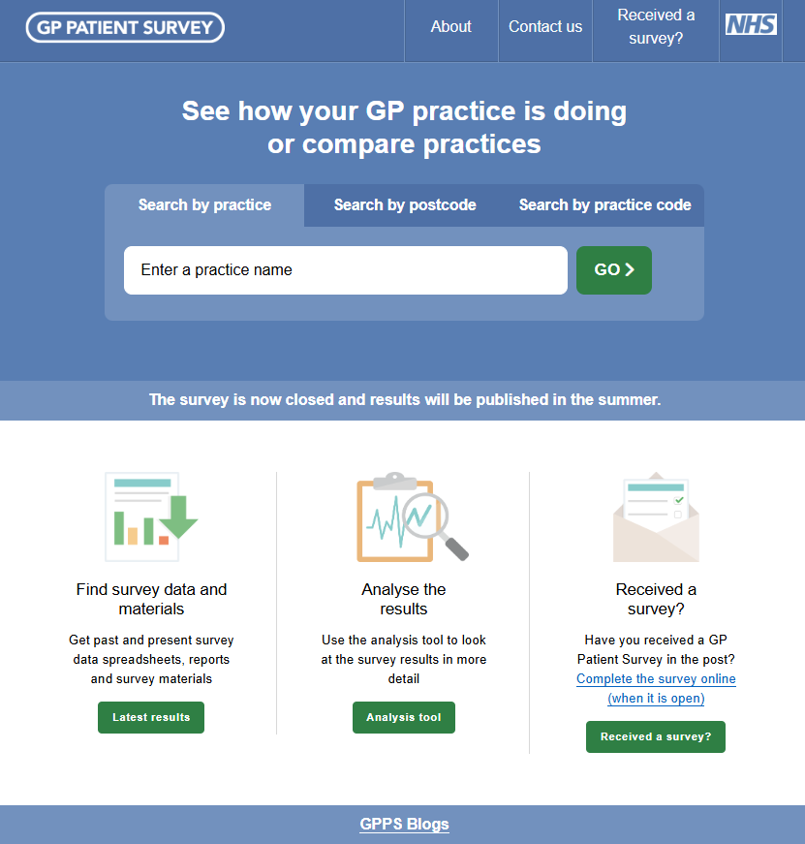
The website is updated on the first day of fieldwork, as the first questionnaires are delivered to patients, to indicate that the survey is open. It consists of a number of sections, detailed below:
- ‘About’ covers the aims of the survey, ways to take part and information about accessibility. This page includes links to information in British Sign Language (BSL) and 14 additional languages which explain the survey, provide responses to a selection of FAQs, and link to online translated versions of the questionnaire.
- ‘Received a survey?’ provides information about the online version of the survey and links to complete it in either English, BSL or another language. This page also includes links to easy read information sheets (both with and without images), an easy read privacy policy and the accessibility page.
- ‘Languages’ provides information about GPPS in British Sign Language (BSL) and 14 additional languages, including Arabic, Bengali, Chinese (Simplified), French, Gujarati, Italian, Polish, Portuguese, Punjabi, Romanian, Slovak, Spanish, Turkish and Urdu. The FAQs (including privacy information), questionnaire, and covering letter are all translated into these languages to make the survey as widely accessible as possible.
- ‘Promote the survey’ provides tips to GP practices for promoting the survey and contains a printable poster in English and 14 other languages.
- ‘Frequently Asked Questions (FAQs)’ includes information about how patients are selected, help with completing the survey, data protection and accessing the results.
- ‘What do you think about the website?’ is a link to a form allowing users to rate the site, provide comments and leave contact details.
- ‘Search for a practice’ takes users to the practice reporting tool, which allows them to view results for a specific practice.
- ‘Compare a practice’ allows users to compare the results of different practices.
- ‘Analysis tool’ is a link to the analysis tool which allows users to interrogate the GPPS data further (see section 8.9: Deliverables).
- ‘Latest results’ takes users to the latest survey datasets, reports, questionnaire, and letters. It also includes an archive of all previous survey results and materials. This can also be accessed via the ‘Past surveys’ link.
- ‘For GP staff’ contains information for GPs about the benefits of the survey.

- ‘Why use the data’ provides information about GPPS, what information can be found in the survey results, and how the website can help the user. It also includes a GP Handbook developed by academic partners giving practices advice on how to use their survey results to improve patient care.
- ‘How do I…?’ provides guidance on how to complete the survey, how to find practice, PCN and ICS data, and how to use the website and analysis tool to conduct further analysis on the data.
- ‘Uses of GPPS’ details a number of examples about how GPPS data is used. This includes uses by national organisations and a series of case studies.
- ‘Privacy notice’ provides information about how the information collected on the GPPS website is used.
- ‘Sitemap’ lists out all the pages on the website.
- ‘Site feedback’ contains contact details for users to provide feedback on the website and includes another link to the user feedback form.
- ‘Contact us’ provides a link to telephone and email contact details for the GPPS team at Ipsos.
- ‘Accessibility’ gives information on how the website can be adapted or used by people with different accessibility requirements, such as by changing the text size, background colours, keyboard navigation or using with a screen reader.
  - Support for participants
    - Telephone helpline
Ipsos offer a Freephone helpline for patients who have any questions about the survey, with separate numbers for English and 14 additional language lines. In total, 17,166 calls and voicemails were handled by the helpline team over the course of 2025 fieldwork.
    - English language telephone helpline
The English language helpline was staffed by a fully trained Ipsos team between 8am and 9pm on weekdays and 10am to 5pm on Saturdays 30 December 2024 to 31 March 2025. Depending on the volume of calls, a voicemail system may be used during quieter periods (see details below). For call handlers to answer patients’ queries, they are provided with a manual containing a complete list of over 300 FAQs. These are updated annually to address any new or emerging queries patients may have. Where the call handlers cannot answer a query, the details are passed on to the GPPS research team who will respond directly.
During quieter periods (generally 10 days after each mailing) the helpline may switch to a voicemail message which briefly explains the purpose of the survey and asks the caller to leave a message and telephone number if they wish to be called back. Call handlers then return the calls within two working days, making up to eight attempts to reach the caller.
During busier periods, the helpline may switch to a holding message that encourages the caller to get in touch via email or call back during a quieter period, to have their query dealt with more quickly.
As well as being a source of information for patients, the helpline also enables sampled patients to complete the survey over the telephone.
In addition, patients can opt out of the survey by providing their access code or contact details to the helpline.
    - Additional language telephone helpline
To make the survey as accessible as possible, there are separate helplines for each of the 14 additional languages that the survey is offered in. Each language has its own Freephone number which is connected to a voicemail message in the corresponding language. As with the English language voicemail, a message briefly explains the purpose of the survey and asks the caller to leave a message and telephone number if they wish to be called back. Ipsos will arrange for Language Line to return the calls within two working days. Again, up to eight attempts are made to return the call. As with the English language helpline, patients are able to complete the survey over the phone or opt out of taking part.
    - Email helpline
As well as using the telephone helpline, patients are also able to email the GPPS team at Ipsos with any queries. In total, 3,263 email queries were received and responded to during fieldwork in 2025.
    - Written correspondence
The survey also generates a large volume of mail returned to the Freepost address, including letters and notes addressed to the survey team or to NHS England. This is separated from the returned questionnaires and delivered to the helpline team on a weekly basis for review. Where a response is requested or deemed otherwise necessary, a written response will be sent to the patient. For 2025 fieldwork 889 letter responses were sent.

    - Safeguarding
Most calls and other correspondence received about the survey are relatively straightforward, and the helpline team are well briefed and experienced in engaging with respondents ethically and sensitively. However, where a cause for safeguarding concern occurs a formal protocol (agreed with NHS England) outlines the procedures that staff should follow. All potential safeguarding cases are reviewed by the research team, and if necessary, escalated to the Ipsos GPPS Ethics Board, a group with particular experience in safeguarding situations. If advised by the Ethics Board, the circumstances are then shared with NHS England. This process ensures all instances are dealt with as sensitively and quickly as possible. For 2025 fieldwork, the Ethics Board reviewed and agreed a course of action for two potential safeguarding queries.
    - Data protection protocols
We have several formal protocols in place to respond to data protection queries, such as subject access requests, requests to update personal information or to delete data. These protocols (agreed with NHS England) outline the steps that will be followed by Ipsos and NHS England in response to these requests. The protocols also include secure storage information and retention periods for these communications.
    - Information for display in GP practices
A poster is made available for GP practices to display in English and 14 additional languages. Copies of the posters are available on the GPPS website for download and printing or displaying on electronic notice boards at www.gp-patient.co.uk/promote.
A communications toolkit is available on the website, designed to help GP practices promote the survey, to raise awareness and encourage selected patients to participate. This includes website and newsletter copy, social media content and FAQs. The toolkit can be found at www.gp-patient.co.uk/promote.
    - Easy read information sheet and privacy policy
An information sheet and privacy policy have been developed and can be found on the website. The information sheet is available with and without images at https://gp-patient.co.uk/easy-read. It provides more information about the survey and how it can be completed. The privacy policy is at www.gp-patient.co.uk/Easy-read-privacy-policy. It provides details about how and why personal data is used on GPPS. Both also direct patients to the helpline to answer any other questions.

5
Data collection

- Data collection
The GP Patient Survey (GPPS) has historically used a simultaneous push-to-web approach, offering the option to take part online or via a paper questionnaire in every mailing. From 2024 onwards, the contact strategy for GPPS has changed to a sequential push-to-web methodology, meaning that a paper questionnaire is only enclosed in the last reminder mailing. This was a result of a series of experiments conducted in 2022 and 2023 which demonstrated that it was possible to save a significant amount of money by removing a paper questionnaire from the first two mailings and, where a mobile phone number was available, to replace the second physical mailing with an e-letter.
To maximise participation, patients can also take part by telephone, and the survey is offered in a variety of accessible formats. The overall contact strategy and processes are described in greater detail below.
Note that although patients are offered several methods of completion, only one completed survey per patient is included in the final data.

  - Contact strategy
Initial letters were sent to all patients in the final sample on the dates in Table 5.1. This was followed one week later by an SMS reminder to all those in the sample with a valid mobile phone number. Two additional reminder mailings were sent; the first an e-letter via SMS (or a paper letter if no mobile number was provided), followed by a second SMS reminder. A final paper reminder mailing followed this, including a paper questionnaire. A third SMS reminder was sent a week after this paper mailing. An additional SMS was sent close to the end of fieldwork to improve response rates.
        - Survey mailout and SMS reminder dates
 | Dates
Initial invitation letter | 30 December 2024 – 2 January 2025
First SMS reminder | 6 – 8 January 2025
E-letter reminder (or letter if no mobile number available) | 20 – 22 January 2025
Second SMS reminder | 27 – 29 January 2025
Final paper mailing (including questionnaire) | 17 – 19 February 2025
Third SMS reminder | 24 – 26 February 2025
Final SMS reminder | 18 – 20 March 2025
Some of the experiment groups followed slightly different mailing timings. More detail on the experiment design can be found in the appendices.
  - Mailing process
The final survey sample is delivered to the printing house via secure file transfer protocol (SFTP), using high level encryption. Upon receipt it is cleaned using the Postcode Address File (PAF), a process which ensures that the letters are sent to the correct postal address and that the mailing is eligible for postage discounts. A downstream access provider is used for processing the mailing packs, with items then handed over to Royal Mail for ‘final mile’ delivery.
All letters and questionnaires are digitally printed as required, ahead of each postal mailing. C5 Business Return envelopes, and C5 outer envelopes are also printed in advance. The letters are personalised with name, address, and the individual’s unique access code, which also appears on the questionnaire. The relevant materials are packed into an outer envelope by machine, and sorted into national or zonal batches, ready for collection by the downstream access provider.
  - Text messages
The final mobile number sample is delivered to the text message provider via secure file transfer protocol (SFTP), using high level encryption. All SMS messages are personalised with a short URL that is unique to each patient, allowing them direct access to the online survey.
To manage the volume of text messages being issued into the mobile network at any time, an automated system schedules a set number of messages in batches, with a maximum of 50 texts per second from 9am to 8:55pm. Each of these were sent over up to four days (Monday to Thursday).
  - Handling reminders
Patients who were not sent a reminder, included those who met the following criteria at the point of the relevant deadline:
- had taken part in the survey online.
- had taken part in the survey via the helpline.
- had telephoned or emailed the helpline and opted out of the survey.
- had opted out via NHS England.
- any letters returned as undeliverable.
- individuals recorded as deceased or no longer eligible on the NHS England database.
As outlined in Chapter 3: Sampling, this year, ahead of delivery of the final mailing packs addresses were reviewed against a database of movers. In order to save on printing and postage costs these people were not sent the final mailing.
  - Online completion
Each patient in the sample is assigned a unique access code (printed on the letter and on the front page of the paper questionnaire) that allows them to access the online survey via the survey website (https://www.gp-patient.co.uk/received-survey) or by using a shortened URL available in the letter (www.gpsurvey.net/login).
To complete the survey online, patients are required either to enter their unique access code on a login screen (see Figure 5.1), or to click on the unique URL in the SMS reminder or e-letter.
      - Login screen for online survey
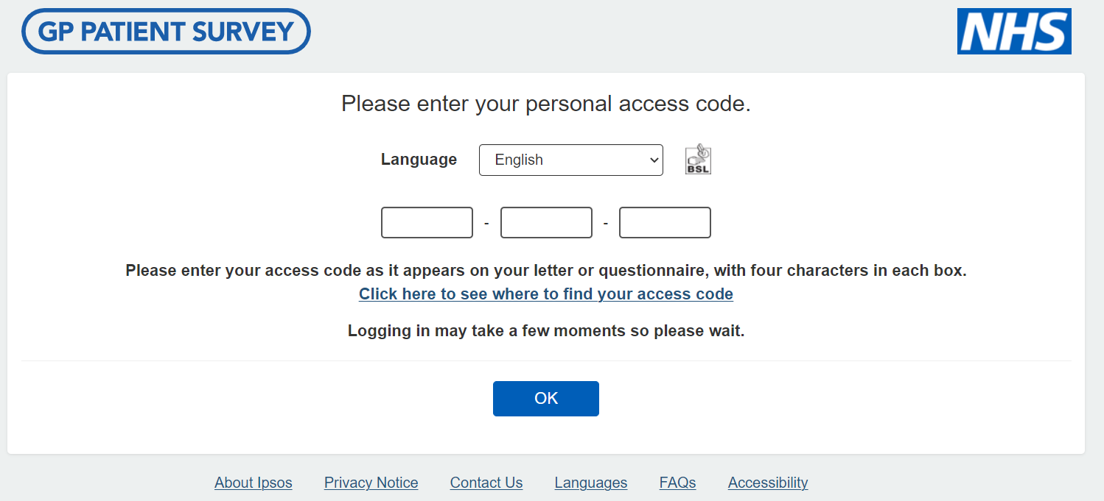
The questions in the online survey are identical to those on the paper questionnaire in terms of wording and design. To ensure comparability between the online survey and paper questionnaire, participants are able to skip questions in the online survey. However, a soft prompt asks them if they are sure they want to skip each question, to encourage completion. The online survey includes large answer option buttons, keyboard navigation, and labelled ‘Next’ and ‘Back’ buttons to improve accessibility. The online survey is also compatible with screen reader software on both desktop and mobile devices.
      - Question from the online survey
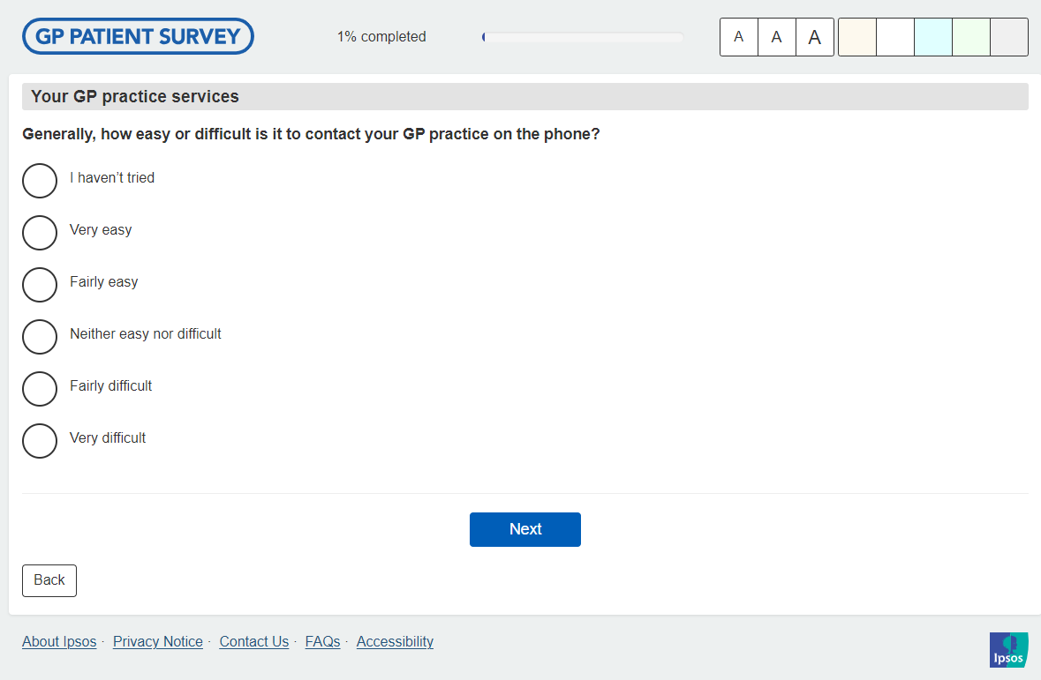
Only one online response per patient is accepted. If patients try to complete the survey more than once online, a message appears letting them know they have already completed it. If they do not complete the survey in one sitting, their unique access code will return them to where they had left off.
    - Total number of online returns
Overall, 585,338 patients completed the survey online during fieldwork in 2025 (compared with 563,585 in 2024). The proportion of patients completing the survey online has increased over time as shown in Table 5.2. The larger increases since 2019 were driven by changes in how participants are approached (e.g. via SMS and removing paper questionnaires from each mailing), designed to drive more people to take part online.

        - Number and proportion of online returns
 | Number of online completes | Online completes as a percentage of all completes
2025 | 585,338 | 83.3%
- 2024 | - 563,585 | - 80.5%
2023 | 344,936 | 45.4%
2022 | 292,929 | 40.7%
2021 | 314,508 | 37.0%
2020 | 150,274 | 20.3%
2019 | 78,657 | 10.2%
2018 | 69,512 | 9.2%
2017 | 47,440 | 6.0%
    - Alternative online formats
Patients are offered several alternative methods of completion to ensure the survey is as accessible as possible. This includes the option to complete the online survey in one of 14 languages offered (in addition to English), or in British Sign Language (BSL). These versions of the survey are accessible from the specific language pages on the website or via a language drop down on the online survey login page (see Figure 5.1). Using one of these routes, patients may choose the language in which they wish to complete the survey (English, Arabic, Bengali, Chinese (Simplified), French, Gujarati, Italian, Polish, Portuguese, Punjabi, Romanian, Somali, Spanish, Turkish or Urdu).
For those entering the online survey via the shortened URL in the letter (www.gpsurvey.net/login) or the short link in the SMS or e-letter, there is a language selection option on the login page (see Figure 5.3).
      - Introduction page for SMS route to online survey with language selection option
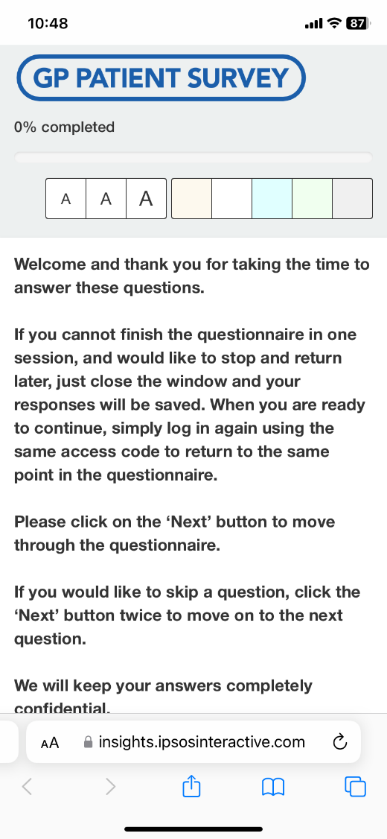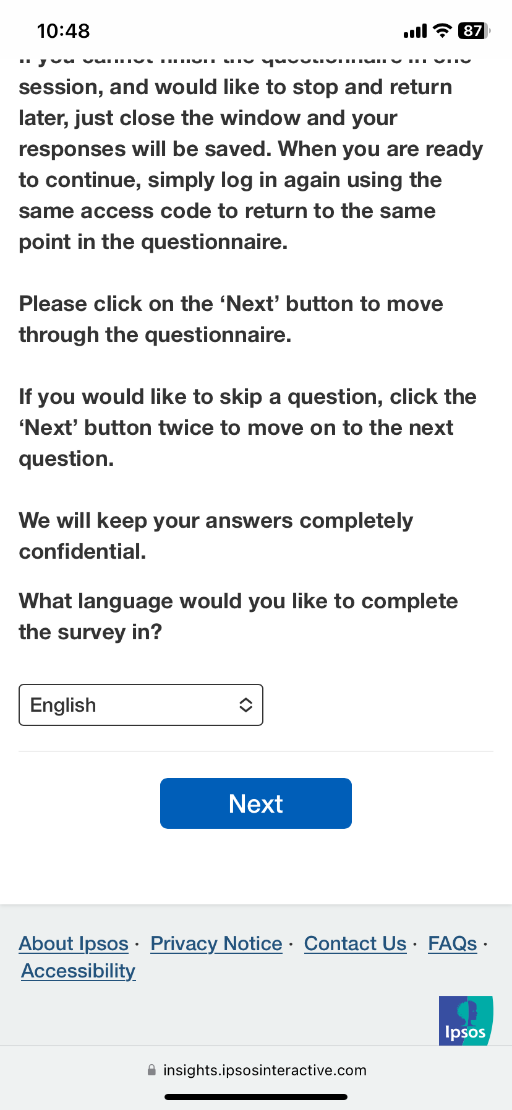
Likewise, the option for patients to access the BSL version is via the page dedicated to supporting BSL users. This involves showing video clips of a BSL user signing the instructions, questions, and options available (see Figure 5.4). There is a BSL logo on the survey log-in page to help promote this option (see Figure 5.1).

Figure 5.4: Viewing the questionnaire in BSL
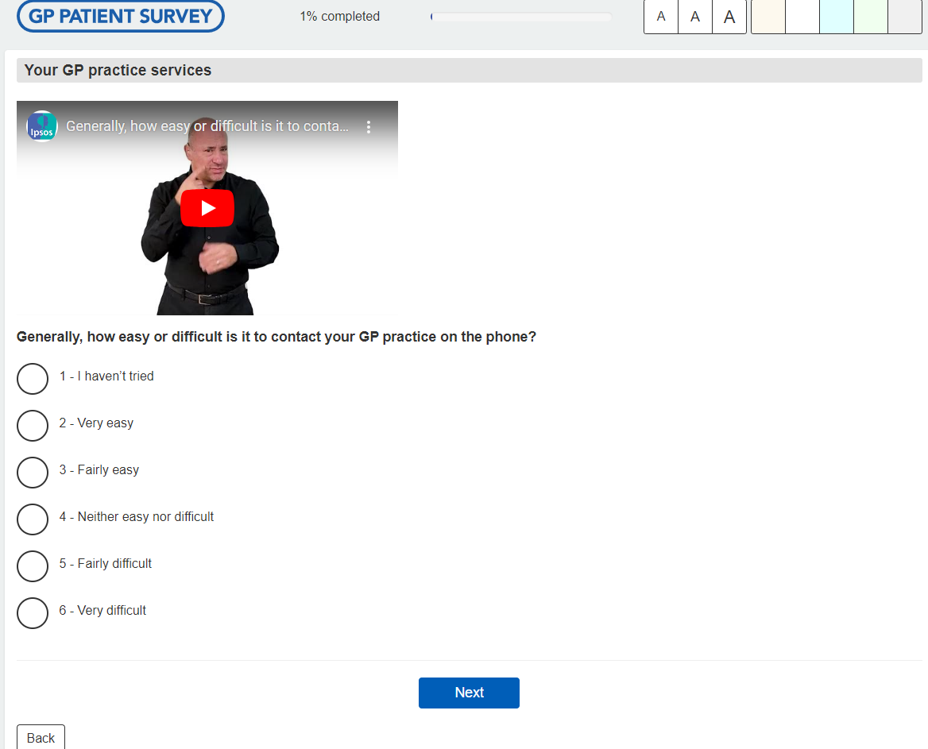

Table 5.3 details how many patients completed the 2025 survey in each available additional language and BSL. There were increases in the number completing online in another language (9,899 in 2025 compared with 9,322 in 2024), and an increase in the number using BSL (378 in 2025 compared with 335 in 2024).
        - Completes per language and BSL
 | Completes
Arabic | 1,132
Bengali | 370
Chinese | 1,169
French | 205
Gujarati | 214
Italian | 246
Polish | 2,557
Portuguese | 745
Punjabi | 325
Romanian | 1,305
Slovak | 184
Spanish | 814
Turkish | 466
Urdu | 167
Total | 9,899
BSL | 378

  - Telephone completion
Patients are also able to complete the GPPS questionnaire on the telephone (including in the 14 additional languages) by calling the Freephone helplines. Patients are asked for their unique access code before they can complete the survey and there is an automatic check on the access code to ensure that it is valid for the live survey. Helpline staff enter callers’ answers directly into the online version of the survey. In total, the helpline team assisted 296 patients in completing the survey during 2025 fieldwork, mostly because they did not have the digital skills or lacked internet access to complete the survey online, but some also had a visual impairment.
In 2022, a Text Relay service was also added to the helpline. However, no participants completed the survey using this service in the 2025 survey.
  - Braille and large print versions
Braille users are offered the opportunity to receive the questionnaire and letter in Braille and can then take part in the survey online. Large print is also made available for those who request a copy of the letter and questionnaire in this format. Returned large print questionnaires are entered manually into the online survey by the helpline team, using the patient’s unique access code. This year there were 89 requests for a large print survey, of which 51 were returned. There were no requests for a Braille version this year.
  - Respondent burden
Respondent burden provides information on the burden of those taking part in the survey. It is calculated using the Compliance Cost Model formula shown below:
$$burden=n_{resp,main_surv }x {med(t}_{main_surv})$$

burden = ‘n_{resp,main_surv}’ multiplied by med(t_{main_surv}).
‘n_{resp,main_surv}’ is the number of responses to the survey, including full and partial responses.
‘med(t_{main_surv})’ is the median time taken to complete the survey.
For the 2025 GP Patient Survey the total compliance cost was 11,562,824 minutes. This is based on 702,837 full completes (online and paper) and 186,611 partial completes (to the online survey), with a median online completion time of 13 minutes.

6
Data analysis

- Data analysis

  - Questionnaire processing
As in previous years, questionnaire data collected online is logically prevented from containing data contrary to the questionnaire instructions (such as multiple responses to a question requiring a single answer).
Paper questionnaires are returned in supplied freepost Business Reply Envelopes (2nd class) to the scanning house. Envelopes are machine opened and questionnaires collated, guillotined and prepared for scanning. Any other items of correspondence are set aside for review and response by Ipsos or NHS England, as appropriate.
Paper questionnaires are scanned and processed using barcode recognition and Optical Mark Recognition technology, with operator verification of uncertain entries. All marks on the forms are recognised at this stage, regardless of whether they are in accordance with the questionnaire instructions.
Paper questionnaires were accepted and included if they were received by 1 April 2025, with the online survey closing the same day.
  - Inclusions and exclusions
The rules and protocols used for delivering the data for the 2025 reports are unchanged from 2024 and are as follows:
- All completed online responses, along with all paper questionnaires received with identifiable reference numbers allowing linkage to a GP practice, are eligible for inclusion.
- Returned questionnaire figures are based only on those qualifying for inclusion in the dataset as described in this document.
- The published response rates are based on all completed, valid questionnaires returned and all questionnaires sent. They have not been adjusted to exclude questionnaires which did not reach the patient, e.g. where envelopes have been returned undelivered etc. However, weighted and adjusted response rates have also been included in Chapter 7: Response rates, which takes into account the selection likelihood and undelivered questionnaires. The following are excluded from the reports:
    - All questionnaires marked as completed by under-16s.
    - All questionnaires where there is only data for a limited number of questions (e.g. only the first page was completed).
    - All questionnaires where the barcode number was not in the valid range for the live wave of the survey.
    - All blank questionnaires.
Questionnaire data are combined from online and scanned data sources. Where duplicates between mode of completion exist, the data used are selected according to the case that is the most complete (i.e. with the fewest unanswered questions). If there is no difference in completeness, the data used are then selected according to a priority order with online data having precedence. Where paper duplicates exist, the earliest return is included.
  - Quality assurance
A number of checks were undertaken at key stages of the survey, including during the sample preparation and data cleaning stages. These help to identify obvious errors in the sample and response data, such as the inclusion of ineligible patients or incorrect coding.
  - Editing the data
The data editing procedures are unchanged for 2025, following the same principles as used previously.
For the completed paper questionnaires, there is a degree of completion error that occurs (e.g. ticking more than one box when only one response is required, answering a question that is not relevant, or missing questions out altogether). Therefore, it is necessary to undertake a certain amount of editing to ensure the data is logical. For example:
  - If a patient ticks more than one box where only one answer is required, then their reply for that question is excluded.
  - Where patients are allowed to select more than one box for a particular question, the reply for that question is excluded if they select two conflicting answers – for example, at Q5 (‘Which of the following online GP services have you used in the last 12 months?’), if a patient ticks any of the first seven options as well as ‘None of these’, then their response for that question is excluded. The following list shows the questions this applies to, as well as the response options that are treated as single code only:
    - Q5 ‘Which of the following online GP services have you used in the last 12 months?’ – ‘None of these’
    - Q14 ‘How did your GP practice deal with your request?’ – ‘I don’t know or I can’t remember’
    - Q15 ‘What did you do when you couldn’t contact your GP practice or didn’t know what the next step would be?’ – ‘I didn’t do anything’
    - Q18 ‘Did you do any of the following before trying to get an appointment with your GP practice?’ – ‘I didn’t do anything before trying to get an appointment with my GP practice’
    - Q19 ‘Were you offered the following choices?’ – ‘I didn’t need a choice’ and ‘I can’t remember’
    - Q30 ‘What was the outcome of the appointment on this occasion?’ – ‘No further action was needed’ and ‘I can’t remember’
    - Q33 ‘In the last 12 months, have you contacted or used an NHS service when you wanted care or advice from a healthcare professional at your GP practice but it was closed?’ – ‘No’
    - Q34 ‘Which of the following services did you contact or use on that occasion?’ – ‘I can’t remember’
    - Q37 ‘Have you experienced any of the following in the last 12 months?’ – ‘None of these’
    - Q39 ‘Which of the following long-term conditions or illnesses do you have?’ – ‘I don’t have any long-term conditions’
    - Q47 ‘Thinking about the last 12 months, which of the following services have you used a pharmacy for?’ – ‘None of these’
    - Q51 ‘Were you able to get an NHS dental appointment?’ – ‘Yes’ and ‘I can’t remember’
  - If all boxes are left blank the reply for that question is excluded.
  - If a patient fails to tick the relevant answer for a filter question any responses are excluded from the subsequent questions relating to the filter question. For example, if a patient responds to Q7 (‘How often do you get to see or speak to your preferred healthcare professional when you ask to?’) without having first responded ‘Yes’ at Q6 (‘Is there a particular healthcare professional at your GP practice you usually prefer to see or speak to?’), their response to Q7 is removed.
  - For the question on whether they have any physical or mental health conditions or illnesses (Q38), patients who initially answer other than 'Yes' have their answer recoded to 'Yes' if they went on to select any physical or mental health conditions or illnesses at Q39.

  - Weighting strategy
The overall approach to weighting for the 2025 survey was consistent with the previous waves, with one notable difference. This year, a small number of additional questions were asked online-only (and included in the accessible formats), but were not included in the paper survey (see Chapter 2: Questionnaire and material design). The online responses and responses received via accessible formats represent 83.3% of the total number of completed surveys.
As a result, a separate weight was created for these questions, because previous testing had shown the demographic profile of respondents who participated in the survey online was different to the profile of respondents to the survey overall. These weights were designed using the same overall approach but with the following differences:
  - the ‘all respondents’ weight, used for analysis of all questions asked via all formats (i.e. online, paper, large print, telephone), treats everyone who responded to the survey as a valid response for weighting.
  - the ‘online-only’ weight, used for analysis of questions asked online and via an accessible format, treats only those who responded using an eligible format (i.e. online, large print, telephone but not on paper) as a valid response.
As this is the first time that the ‘online only’ questions (i.e. those not included on the paper questionnaire) are being published, they have been classified as ‘Official Statistics in development’. The trustworthiness, quality and value of these will be evaluated with a view to removing the ‘in development’ label in time.
Both weights were generated using the same approach, to correct for the sampling design and to reduce the impact of non-response bias. These weights were calculated using the following three stages:
  - Step 1: creation of design weights to account for the unequal probability of selection.
  - Step 2: generation of non-response weights to account for differences in the characteristics of responders and non-responders.
  - Step 3: generation of calibration weights to ensure that the distribution of the weighted responding sample across practices resembles that of the population of eligible patients, and that the age and gender distribution within each Integrated Care System (ICS) matches the population of eligible patients within the ICS.
Design weights were computed to correct for the disproportionate sampling of patients by GP practice, as the inverse of the probability of selection, i.e. by dividing the total number of eligible patients in the practice at the time of sampling by the number sampled. This was the same for both the ‘all respondents’ and ‘online-only’ weights.
Non-response weights were constructed using a model-based approach to estimate the probability of taking part in the survey. These were calculated separately for the ‘all respondents’ and ‘online-only’ weights. These models, created using the current year’s data, estimated the probability of responding based on the age and gender of the patient and the socio-economic characteristics of the neighbourhood in which the patient lived. These weights aim to reduce the demographic and socio-economic differences between respondents and non-respondents.
Data from the GPPS sampling frame (patient’s age, gender, and region) was linked to external data using the home postcode of the patient. This consisted of measures from the 2021 Census: output area aggregated measures of ethnicity, marital status, overcrowding, household tenure and employment status, as well as the indicator of multiple deprivation score (IMD) and ACORN group.
The probability of response was estimated using a logistic regression model with eligible response (or not) as the outcome measure and the measures described above included as covariates. Standardised design weights were applied when running the model to obtain unbiased estimates for the coefficients – to ensure that the design effects were accounted for within the model (e.g. the oversampling of smaller practices).
The models allow us to identify patterns in non-response behaviour: female patients were more likely to respond than male patients, younger patients were less likely to respond than older patients. There were also some differences by region, with response lowest in London and the North West, and highest in the South West. Response was also lower in ACORN groups T (‘Constrained Pensioners’), S (‘Cash-strapped Families’) and U (‘Challenging Circumstances’).
Response also decreased for patients living in Census Output Areas (OAs) with the following characteristics:
  - higher levels of deprivation based on IMD scores.
  - a higher proportion of people from ethnic minority backgrounds.
  - a higher proportion of single, separated, or divorced people.
  - a higher proportion of households with three or more people.
  - a higher proportion of privately rented households; and/or
  - a lower proportion of employees.
The non-response weights were calculated as the reciprocal of the predicted probability of response estimated from the model. To avoid very large weights, the non-response weights were capped for the 1% largest values. The non-response weights were multiplied by the design weight to obtain the starting weights for the calibration.
The starting weights were then calibrated to practice population counts, and to population counts by age / gender within each ICS. These calibrations were run separately for the ‘all respondents’ and ‘online-only’ weights. The population totals used for the calibration were estimated from the sampling frame.
To avoid very large weights, the ratio of the calibration weights to their starting weights was trimmed at a value of 2.5. Finally, the weights were separately standardised to sum to their relevant sample size.
  - Unweighted and weighted respondent profiles
The tables below show the unweighted and weighted profiles of patients taking part in the survey. These are based on self-reported responses to the survey, with the exception of Index of Multiple Deprivation (IMD) which is derived from the individual’s postcode.
 | Unweighted  N | Unweighted  % | Weighted  N | Weighted  %
Which of the following best describes you?
Female | 400,408 | 57.1% | 360,765 | 51.4%
Male | 292,693 | 41.8% | 329,652 | 47.0%
Non-binary | 1,134 | 0.2% | 2,366 | 0.3%
Prefer to self-describe | 1,013 | 0.1% | 1,457 | 0.2%
I would prefer not to say | 5,811 | 0.8% | 7,163 | 1.0%
Is your gender identity the same as the sex you were registered at birth?
Yes | 686,823 | 98.3% | 684,042 | 97.8%
No | 3,831 | 0.5% | 6,038 | 0.9%
I would prefer not to say | 7,904 | 1.1% | 9,619 | 1.4%

 | Unweighted  N | Unweighted  % | Weighted  N | Weighted  %
Age
16-24 | 25,108 | 3.6% | 63,011 | 9.0%
25-34 | 50,568 | 7.2% | 115,433 | 16.5%
35-44 | 80,865 | 11.5% | 125,511 | 17.9%
45-54 | 109,975 | 15.7% | 117,517 | 16.7%
55-64 | 157,835 | 22.5% | 115,547 | 16.5%
65-74 | 149,075 | 21.3% | 82,719 | 11.8%
75-84 | 99,152 | 14.1% | 57,777 | 8.2%
85+ | 23,863 | 3.4% | 19,003 | 2.7%
I would prefer not to say | 4,997 | 0.7% | 5,201 | 0.7%
Ethnicity
White | 559,234 | 80.7% | 535,903 | 77.1%
Mixed or multiple ethnic groups | 10,652 | 1.5% | 14,830 | 2.1%
Asian or Asian British | 68,726 | 9.9% | 80,637 | 11.6%
Black, Black British, Caribbean or African | 37,393 | 5.4% | 42,802 | 6.2%
Other ethnic group | 10,065 | 1.5% | 11,766 | 1.7%
I would prefer not to say | 7,223 | 1.0% | 8,793 | 1.3%
Sexuality
Heterosexual or straight | 629,757 | 90.5% | 613,319 | 87.9%
Gay or lesbian | 11,146 | 1.6% | 16,464 | 2.4%
Bisexual | 9,585 | 1.4% | 16,757 | 2.4%
Other | 7,648 | 1.1% | 9,591 | 1.4%
I would prefer not to say | 37,513 | 5.4% | 41,600 | 6.0%

 | Unweighted  N | Unweighted  % | Weighted  N | Weighted  %
Religion
No religion | 215,312 | 30.8% | 258,839 | 37.0%
Buddhist | 4,704 | 0.7% | 5,160 | 0.7%
Christian | 376,462 | 53.9% | 320,956 | 45.9%
Hindu | 14,788 | 2.1% | 16,850 | 2.4%
Jewish | 3,738 | 0.5% | 3,209 | 0.5%
Muslim | 42,228 | 6.0% | 49,700 | 7.1%
Sikh | 6,681 | 1.0% | 6,378 | 0.9%
Any other religion | 8,047 | 1.2% | 8,847 | 1.3%
I would prefer not to say | 26,313 | 3.8% | 29,351 | 4.2%
Carer
Carer | 124,642 | 17.9% | 113,350 | 16.2%
IMD deprivation quintiles
Most deprived 1 | 144,543 | 20.6% | 148,054 | 21.1%
2 | 141,795 | 20.2% | 147,684 | 21.1%
3 | 143,731 | 20.5% | 140,855 | 20.1%
4 | 139,596 | 19.9% | 133,618 | 19.1%
Least deprived 5 | 131,221 | 18.7% | 130,314 | 18.6%
Disability
Disability | 273,402 | 38.9% | 249,128 | 35.4%
Number of long-term conditions
1 | 214,028 | 32.5% | 209,348 | 31.9%
2 | 123,862 | 18.8% | 104,513 | 15.9%
3+ | 128,671 | 19.5% | 98,793 | 15.0%

  - Confidence intervals
- Estimates from the GPPS are based on a sample of the population. Therefore, they are measures with some uncertainty. This uncertainty is represented by applying confidence intervals, which are ranges within which we are fairly confident (95%) that the true population value lies had everyone eligible for the survey been sampled and returned a questionnaire.
- The table below gives examples of what the 95% confidence intervals look like for indicative percentage survey results from a practice, PCN and ICS with an average number of responses, as well as the confidence intervals at the national level, based on weighted data.
        - Confidence interval examples for practices, PCNs, ICSs and national data
 | Average number of responses on which results are based | Approximate confidence intervals for percentages at or near these levels
 | Average number of responses on which results are based | Level 1:  10% or 90% | Level 2:  30% or 70% | Level 3:  50%
 | Average number of responses on which results are based | +/- (percentage points) | +/- (percentage points) | +/- (percentage points)
National | 702,837 | 0.11 | 0.16 | 0.18
ICS | 16,734 | 0.68 | 1.03 | 1.13
PCN | 539 | 3.42 | 5.22 | 5.70
Practice | 113 | 6.86 | 10.48 | 11.43
- For example, in an ICS where 16,734 people responded (the average number of responses at ICS level) and where 30% give a particular answer, the confidence interval is +/- 1.03 percentage points from that survey estimate (i.e. between 28.97% and 31.03%). The confidence intervals published here are a guide to the size of the confidence intervals around the GPPS data. Confidence intervals are also affected by weighting and are wider where results are based on a smaller number of responses.
- Lower and upper limits for confidence intervals for a selection of questions are presented in the practice, PCN and ICS Excel reports on the Surveys and Reports page of the website.

- Within the context of GPPS, where some satisfaction scores are around 99%, there is more scope for a survey estimate to fall below 99% than above, purely because there are far more possible lower scores (this makes sense intuitively as well as probabilistically). The confidence interval has to take this limit into account, and, in such circumstances, the lower limit is expected to be larger than the upper limit. As a result, Wilson’s method is used to calculate confidence intervals, which accounts for this, and permits intervals to be asymmetric – i.e. the lower and upper limits can be unequal in size (unlike other confidence interval tests).
- Power calculations are carried out to estimate the size of the real effect that would be required to be likely to find a statistically significant difference in the statistical test performed. This level of likelihood is called “power”, and the acceptable level is usually set at 80%, i.e. the difference would be significant for 80% of the tests on average if the survey was repeated. Like the confidence intervals, the power calculations are based on weighted data. The following table shows the size of the real percentage point (pp) difference in the population between a pair of ICSs, pair of PCNs and pair of practices with an average number of responses, that would be detected with 80% power in the survey data.
        - Power calculations for PCNs, ICSs and practices
 |  | Average number of responses on which results are based | Difference between the two estimates
 |  | Average number of responses on which results are based | Level 1:  Lower estimate = 10% | Level 2:  Lower estimate = 30% | Level 3:  Lower estimate = 50%
 |  | Average number of responses on which results are based | +/- (percentage points) | +/- (percentage points) | +/- (percentage points)
ICS | 16,734 |  | 1.4 | 2.1 | 2.3
PCN | 539 |  | 8.0 | 11.0 | 11.4
Practice | 113 |  | 18.2 | 22.8 | 22.5

Using an example, comparing two practices with the same number of responses (113), if the result for the first practice was that 50% of patients said their experience of making an appointment was good (‘very good’ or ‘fairly good’), then the percentage in the second practice would need to be at least 27.5% or at most 72.5% for a statistical difference to be identified between these two practices with an acceptable level of statistical power (80%) i.e. 22.5 percentage points higher or lower, as outlined in the table above.

7
Response rates

- Response rates

  - Unadjusted response rates (published)
The overall response rate for England was 25.8%, based on 2,721,415 questionnaires sent out and 702,837 returned.
        - Surveys sent, returned and response rates
 | Number sent | Number returned | Response rate
Total | 2,721,415 | 702,837 | 25.8%
        - Response rates for female and male
 | 2025
Female | 29.9%
Male | 21.9%
        - Response rates by age
 | 2025
16-17 | 14.4%
18-24 | 8.5%
25-34 | 10.6%
35-44 | 16.1%
45-54 | 25.8%
55-64 | 39.6%
65-74 | 53.1%
75-84 | 52.1%
85+ | 35.5%

      - Number of practices within each response rate band over time

        - Number and proportion of practices within each response rate band
 | Practices in 2025 |  | Practices in 2024 |  | Practices in 2023 |  | Practices in 2022 |  | Practices in 2021
 | No | % | No. | % | No. | % | No. | % | No. | %
0-9% | 128 | 2% | 79 | 1% | 77 | 1% | 74 | 1% | 84 | 1%
10-19% | 1,148 | 18% | 1,003 | 16% | 834 | 13% | 810 | 12% | 382 | 6%
20-29% | 2,043 | 33% | 1,827 | 29% | 1,822 | 28% | 1,823 | 28% | 1,313 | 20%
30-39% | 2,039 | 33% | 2,152 | 34% | 2,111 | 33% | 2,215 | 34% | 1,847 | 28%
40-49% | 815 | 13% | 1,119 | 18% | 1,385 | 22% | 1,423 | 22% | 1,965 | 30%
50-59% | 56 | 1% | 125 | 2% | 185 | 3% | 160 | 2% | 999 | 15%
60-69% | 1 | * | 2 | * | 4 | * | 2 | * | 68 | 1%
Total | 6,230 | 100% | 6,307 | 100% | 6,418 | 100% | 6,507 | 100% | 6,658 | 100%

For response rates prior to 2021, please see the 2020 technical annex.
      - National response rates to the survey over time
Biannual
Annual
Annual
Quarterly
  - Adjustments to response rate
Alternative presentations of response rates can mitigate the effects that some elements of a survey’s methodology might have on the response rate calculation. Two such presentations are explained below.
    - Weighted response rate
As described in Chapter 3: Sampling, the issued samples in GP practices with lower response rates are boosted to achieve a minimum sample size. One implication of this is that the issued sample is skewed towards GP practices where participation is likely to be lower. In other words, a patient registered at a practice with a low response rate has a higher chance of being selected for the GPPS than one at a same-sized practice with a high response rate. As a result, one would expect to observe a lower response rate overall compared with a design in which the sample was allocated to GP practices in proportion. Further, it means that comparisons of response rates between waves and with other surveys could be misleading as, by design, the GPPS over-samples patients who are less likely to participate, to ensure sufficient results are achieved from as many practices as possible.
To demonstrate the impact of this, it is recommended that both unweighted and weighted estimates of response rates are presented for samples with unequal selection weights. For example, Lynn et al. write that:
‘The importance of weighted outcome rates stems from the possibility that response rates could differ across strata or other intermediate sampling units which have different inclusion probabilities.’
Lynn et al.
For the GPPS sample, we know by design that the GP practices (the strata) in which patients have a higher inclusion probability are those with a lower response rate. A weighted response rate can therefore be calculated with the issued sample weighted by the original selection weight.
    - Adjusted response rate
It is also standard practice on many surveys to adjust the response rate to take into account the ineligible sample, i.e. participants who could never have been contacted or received a survey during the fieldwork period. For a push-to-web survey it is difficult to calculate the postal element, but taking a conservative approach, it is possible to exclude undeliverable post, so those who did not receive a questionnaire pack. This is referred to as an adjusted response rate.

Table 7.5 presents both the weighted and adjusted response rates alongside the published (unweighted and unadjusted) response rate.
        - Unweighted, weighted and adjusted response rates
 | Unweighted/unadjusted response rate (published) | Weighted response rate (unadjusted) | Adjusted response rate (unweighted)
2025 | 25.8% | 29.4% | 26.8%

8
Reporting

- Reporting

  - Official statistics status of GPPS results
GPPS results are official statistics. Official statistics are statistics produced on behalf of the UK government. Producers of official statistics follow the professional standards in the Code of Practice for Statistics, to provide official statistics that serve the public good. For more information on the Code of Practice for Statistics, please see the UK Statistics Authority website at: https://code.statisticsauthority.gov.uk/
However, this year, in addition to the core (online and paper) questionnaire, a small number of additional questions were included in the online version of the survey only. It was not possible to include these in the paper questionnaire due to space constraints. A list of these online-only questions is available in section 2.2.
The inclusion of online-only questions is a new development for GPPS and, as such, results for these questions are labelled as ‘official statistics in development’, in line with the standards in the Code of Practice for Statistics. The trustworthiness, quality and value of these statistics will be evaluated with a view to removing the ‘in development’ label in time. As a result, user feedback on the need for these statistics and how they are being used is important. Please share any feedback on the online-only questions with: GPPatientSurvey@ipsos.com.
  - Presentation of results
Many of the GP Patient Survey (GPPS) outputs lead with a summary result; a single statistic that provides a quick way of viewing the result for a question. This is usually an aggregation of two individual responses (e.g. ‘% Easy’ is a combination of ‘% Very easy and ‘% Fairly easy’) or a single response option (e.g. ‘% Yes’).
For some questions it is not appropriate to present a summary result; for instance, where it is more useful to look at the responses individually and there is not a particular answer that suggests a more (or less) positive experience. An example of this is Q5 ‘Which of the following online GP services have you used in the last 12 months?’.
  - Calculation of results and percentages
Typically, all response options are included in the calculation of a question result. However, for some questions certain response options are excluded from the result where appropriate (e.g. 'I haven’t tried', 'I can’t remember', 'I don’t know'), to provide a more accurate reflection of how those using a service evaluate it. These responses in general do not provide information about a patient’s experience of primary care services. If a response is excluded from a result, these are noted in the Presentation of results.

Using Question 1 as an example, removing those who said ‘I haven’t tried’ to get through to their GP practice on the phone from the calculation provides a better reflection of the views of patients who had tried. This is shown in the table below using dummy data. Numbers and percentages are presented for the five response options ‘Very easy’, ‘Fairly easy’, ‘Neither easy or difficult’, ‘Fairly difficult’, and ‘Very difficult’.
Q1 Generally, how easy or difficult is it to contact your GP practice on the phone?
Results |  |  | Summary results
 | n | % |  | n | %
I haven’t tried | / | / | / | / | /
Very easy | 20 | 20% | Easy | 45 | 45%
Fairly easy | 25 | 25% | Easy | 45 | 45%
Neither easy nor difficult | 25 | 25% | / | 25 | /
Fairly difficult | 15 | 15% | Difficult | 30 | 30%
Very difficult | 15 | 15% | Difficult | 30 | 30%
Base | 100 | 100% |  | 100 | 100%
In addition, there are six questions where the excluded response option percentages are presented separately in some reports, as these are likely to be of particular interest:
- Question 1: ‘I haven’t tried’ – Generally how easy or difficult is it to contact your GP practice on the phone?
- Question 2: ‘I haven’t tried’ – Generally how easy or difficult is it to contact your GP practice using their website?
- Question 3: ‘I haven’t tried’ – Generally how easy or difficult is it to contact your GP practice using the NHS App?
- Question 7: 'I haven’t tried’ – How often do you get to see or speak to your preferred healthcare professional when you ask to?
- Question 19: 'I didn't need a choice' – Were you offered the following choices?
- Question 43: 'I haven't needed support' – In the last 12 months, have you had enough support from local services or organisations to help you manage your conditions or illnesses?
Some questions in the survey are multiple choice, allowing patients to provide more than one response to a question. An example of this is Q5 (Which of the following online GP services have you used in the last 12 months?). For these questions, percentages are calculated using the total number of people who responded to the question as the denominator.
If you have any questions about the presentation of the results, please email the Ipsos research team.
  - Trend data
Every year the questionnaire content is reviewed to reflect the changing primary care context and priorities. This led to minor changes to the wording of some of the response options for two questions which has impacted trends. These changes have affected the comparability of these questions, even though question wording remains the same. This is because it is difficult to determine whether a difference in results is caused by the change to the response options or a 'real difference'.
- Trends are not presented for Q9: 'On that occasion, what was your main reason for trying to contact your GP practice?'
- Trends are not presented for the long-term condition ‘Arthritis or problem with your back or joints' at Q39 ('Which of the following long-term conditions or illnesses do you have?) and the 2024 response option ('Joint problem, such as arthritis') as these are not directly comparable.
More information on the changes to the questionnaire is available in Chapter 2: Questionnaire and material design. For an overview of the changes to the 2025 survey, please see the Changes to the 2025 survey.
Additional historical data is available for GPPS on the survey website. Prior to the questionnaire redevelopment in 2024 (and the start of a new time series) there have been a number of key breaks in trends to note. This includes a previous significant change to the questionnaire and extension of the sampling frame to include 16- and 17-year-olds in 2018. Please see the 2018 Technical Annex for further detail.
In addition, analysis in Year 11 (2017) identified a fieldwork timing effect, the impact of the survey moving from a bi-annual format (between 2011 and 2016) to annual in 2017. This found evidence of systematic differences in the data collected between the Wave 1 (July-September) and Wave 2 (January-March) fieldwork periods. For full details of this analysis please see the Technical note on fieldwork timing effect.
Finally, please note if manually comparing data from 2019 onwards with 2018 using the Excel/csv reports published in their respective years, the percentages for some questions are calculated differently (as outlined in the ‘Calculation of results’ section above), and care should be taken to ensure that any results are compared on the same basis. Please see the Presentation of results document for further information.

  - Suppression
Suppression is used to prevent individuals and their responses being identifiable in the data, and to ensure results based on very small numbers of respondents are not released.
The GP Patient Survey uses two types of suppression:
- In cases where a result is based on fewer than 10 people (unweighted), it has been suppressed. For example, where fewer than 10 people answered a question from a particular organisation, the results are not shown. This method was amended in 2023 to use just the unweighted base.
- In addition, for organisations with an eligible population of 1,000 or less, individual response option counts below 5 (but excluding 0) and corresponding percentages have been suppressed for the relevant questions in the 'Some questions about you' section and questions identifying participants as having, or not having, long-term conditions, disabilities, or illnesses. In instances where only one response option is suppressed for these questions, the next lowest response option has also been suppressed to prevent back calculation of the primary suppressed result. The questions which this suppression method relates to are listed in the table 8.1 below. ‘Population’ for the GP Patient Survey is defined as the number of patients on the GP registered list for that organisation.
‘Population’ for the GP Patient Survey is defined as the number of patients on the GP registered list for that organisation.
Please note due to the technical limitations of the analysis tool and the PCN dashboard it has not been possible to apply this suppression method to the affected organisations and questions. As such, these specific question results for these organisations are not available in these outputs. The number of organisations affected for the relevant questions is very small. To see the full results for an organisation, if not available in the tool or dashboard, please visit the Survey and Reports page: https://www.gp-patient.co.uk/surveysandreports.
An additional suppression measure has been taken for Q38 (‘Do you have any physical or mental health conditions or illnesses lasting, or expected to last, 12 months or more?’) due to the question including a response that is excluded from percentage calculations. Where fewer than 5 or more than 0 patients selected ‘I don’t know’, the total base has been suppressed to prevent back-calculation of a suppressed response.
        - List of quasi-identifiable questions
 | Question text
Long-term condition status (Q38) | Do you have any physical or mental health conditions or illnesses lasting, or expected to last, 12 months or more?
Long-term condition (Q39) | Which of the following long-term conditions or illnesses do you have?
Long COVID (Q40) | Would you describe yourself as having ‘long COVID’? That is, you are still experiencing symptoms more than 12 weeks after you first had COVID-19 that are not explained by something else?
Age (Q54) | How old are you?
Which of the following best describes you? (Q55) | Which of the following best describes you?
Is your gender identity the same as the sex you were registered at birth? (Q56) | Is your gender identity the same as the sex you were registered at birth?
Sexual orientation (Q57) | Which of the following best describes how you think of yourself?
Ethnicity (Q58) | What is your ethnic group?
Religion (Q59) | Which, if any, of the following best describes your religion?
Occupation status (Q60) | Which of the following best describe what you are doing at present?
Carer status (Q61) | Do you look after, or give any help or support to, anyone because they have long-term physical or mental health conditions or illnesses, or problems related to old age?
Parent or legal guardian status (Q62) | Are you a parent or a legal guardian of any children aged under 16 living in your home?
  - Weighting
All published GPPS outputs show the weighted results. Weighting ensures results are more representative of the population of patients aged 16 or over registered with a GP practice. Unweighted base sizes, alongside weighted base sizes, are reported in most outputs to provide transparency on the actual number of patients who responded to a question.
Further information of the weighting strategy is provided in section 6.5.
  - Organisation mapping
- GP practices are mapped to Integrated Care Systems and NHS Regions using the ‘epraccur’ file and are mapped to Primary Care Networks using the ‘ePCN’ file, both available from NHS England Digital. The ‘epraccur’ and ‘ePCN’ files used are the versions available at the end of fieldwork (March/April) , therefore results are presented under the latest organisation names available upon fieldwork closing.
- Practices are mapped to organisations (sub-ICB, ICB and region) based on the commissioner for the GP practice. Please note this mapping in some cases may not reflect where patients live. For example, the survey includes participants who are registered with a GP practice in England but live in Wales.
  - Changes to reporting outputs
Each year the reporting outputs are reviewed based on feedback from users and against the NHS Information Standards and other government guidance for publishing statistical publications. The changes for 2025 are minor, and include the publication of a regional csv data file to support users with regional level analysis. All changes are outlined in the Changes to the 2025 survey.
  - Deliverables
The survey reporting specifications were created by Ipsos in collaboration with NHS England. The specifications detail the content and layout of each of the outputs (Excel, PowerPoint reports, Power BI and SPSS datasets).
All data and reports are encrypted and supplied to NHS England via a secure FTP (File Transfer Protocol) site. Ipsos work closely with NHS England to quality assure the data and reports. In 2025 a different approach has been adopted. Whereas in previous years NHS England independently verified each report and dataset, this is now done for the national data and reports only. For all other outputs Ipsos share comprehensive quality assurance evidence with NHS England.
Tables 8.2 to 8.4 describe the reports and datasets which are produced, including the presentation of statistics in each.
        - Reports (published via the www.gp-patient.co.uk website)
 | Detail / purpose
National report | National results presented in a PowerPoint report
National results | National results for all questions, presented in table format (Excel)
National infographic | Selected national headline results in a visual format
ICS slide packs | 42 PowerPoint reports containing results for a selection of key questions for individual ICSs (and variation by PCN within ICS)
PCN dashboard (PowerBI)  (gp-patient.co.uk/pcn-dashboard) | An interactive, visual tool showing results for each PCN (Primary Care Network) in PowerBI, hosted on the GPPS website, showing variation by practice within PCN and comparisons with national results
Patient experience and compare practices tool  (gp-patient.co.uk/practices-search) | Results for a selection of key questions for individual practices (alongside ICS and national results)  Compare a practice with up to two other practices  Filter results by demographics (age, ethnicity, long-term condition, or disability status)
GP practice output | Downloadable results for every GP practice in a visual PowerPoint format for a selection of questions
Analysis tool  (gp-patient.co.uk/analysistool) | Use the analysis tool to look at the survey results (at national, ICS, PCN and practice level), and to analyse results for specific groups of patients (e.g. by age, ethnicity and more)
National data (.csv) | A CSV (Comma-separated value) file that contains the national-level results.
Regional data (.csv) | A CSV (Comma-separated value) file that contains the regional-level results.
ICS results (Excel) | An Excel report containing the ICS-level results and the national results presented in a table format
ICS data (.csv) | A CSV (Comma-separated value) file that contains the ICS-level results.
PCN results (Excel) | An Excel report containing the PCN-level results and the national results presented in a table format
PCN data (.csv) | A CSV (Comma-separated value) file that contains all the PCN-level results.
Practice results (Excel) | An Excel report containing the practice-level results and the national results presented in a table format
Practice data (.csv) | A CSV (Comma-separated value) file that contains all the practice-level results

        - Weighted and unweighted datasets provided to NHS England (not published)
 | Detail / purpose
Person dataset | Person level dataset (SPSS) to allow for a range of further analysis
Practice dataset | Practice level dataset (SPSS) to allow for a range of further analysis
PCN dataset | PCN level dataset (SPSS) to allow for a range of further analysis
ICS dataset | ICS level dataset (SPSS) to allow for a range of further analysis
National dataset | National level dataset (SPSS) to support further analysis
Dentistry person dataset | Person level dataset (SPSS) to allow for a range of further analysis based on dentistry questions

        - Technical documents (published via the website)
 | Detail / purpose
Technical annex | Report to communicate operational details of survey
Presentation of results | Excel report to explain how results are calculated and presented across the various survey outputs
List of reporting variables | A CSV (Comma-separated value) file that lists all the survey questions and where you can find them in the CSV files
Changes to the survey | A report to explain the year-to-year changes made to the survey

  - The GPPS ‘Surveys and Reports’ page
The Survey and Reports page on the GPPS website allows users to access and download the published surveys and reports including ICS slide packs, the PCN dashboard, Excel/csv reports, and National Infographic. Users select the latest or past survey results and materials, and are presented with the materials relevant to that publication, organised at national, ICS, PCN and practice level. Users can access all published current and archived reports from 2007 onwards.
      - Survey and reports page on the GPPS website
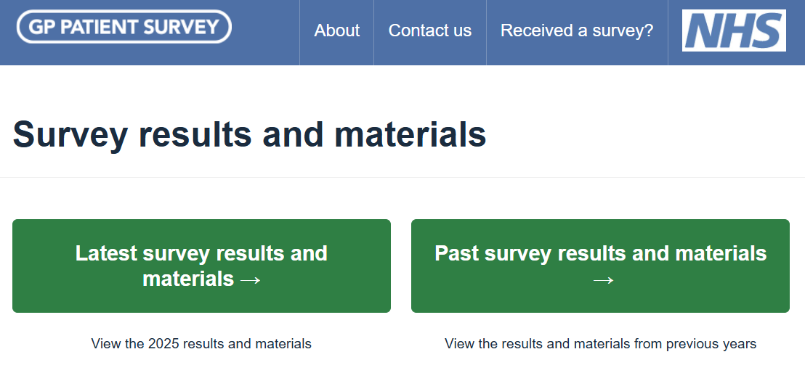
All current reports for national, ICS, PCN and practice level are accessible through this page, along with the other published reports as detailed in Tables 8.2 to 8.4. Please note that prior to 2022, reports are available for Clinical Commissioning Groups (CCG). These are no longer provided following changes to NHS reporting geographies: CCGs were abolished by the Health and Care Act 2022 and their powers transferred to Integrated Care Systems (ICS). Reports are now available for Primary Care Networks (PCN) and Integrated Care Systems (ICS).
The ICS slide packs can be accessed by using the ICS drop down or the green button under ‘Additional outputs’. The slide packs are grouped by NHS region and listed alphabetically under each, to allow easy access to the PowerPoint reports (see Figure 8.2). ICS slide packs are also available for the 2024, 2023, 2022 and 2021 surveys. Prior to 2021, organisation slide packs were available at CCG level for the January 2015 publication onwards.
      - ICS slide packs page
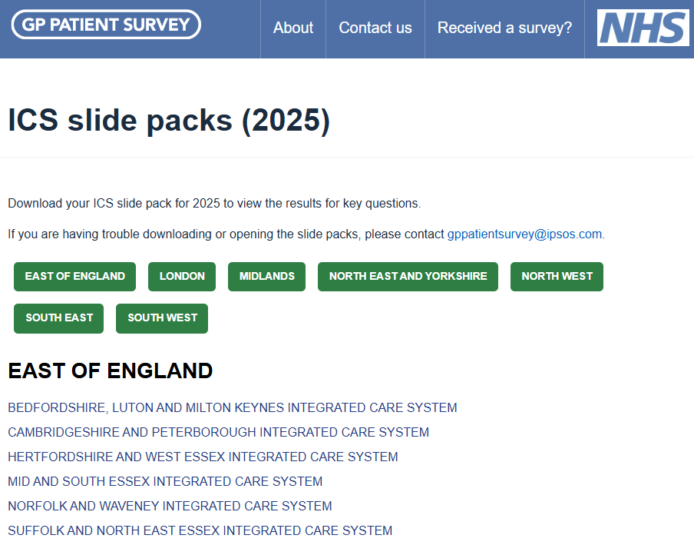
The PCN dashboard can be accessed by using the PCN drop down or the green button under ‘Additional outputs’. The dashboard provides an interactive tool with results for all questions for individual PCNs (including variation by practice within PCN for the latest years’ data) (see Figure 8.3).
      - PCN dashboard
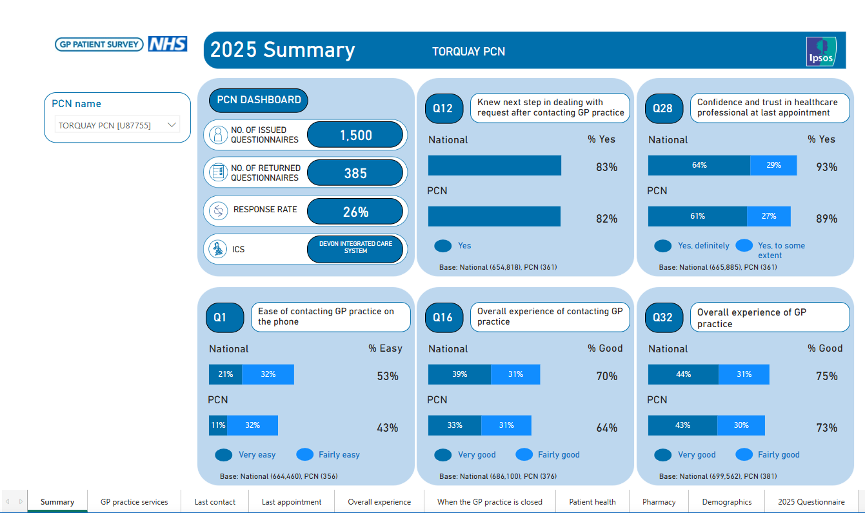
  - The GPPS analysis tool
The GPPS analysis tool is designed to help users analyse GPPS data. It allows analysis of the results for the current survey year, provides trend data (showing 2024 and 2025 results only due to changes in the questionnaire and survey methodology) and includes a crosstabulation function.
    - 2025 results
From the main Analysis Tool homepage users select 2025 results, which allows them to look at the data from the most recent publication.
Results can be viewed at practice, PCN, ICS, and national level. After selecting an organisation level there are two options:
- View Results: this section of the website allows the user to select a question or series of questions and view the results as a table or chart for their selected organisations These findings can be filtered based on different patient groups, for example, by age, ethnicity or long-term condition.
- It is also possible to add other organisation results. Up to four additional geographies or organisations may be added for comparison.
  - When selecting a practice, for example, add one additional practice result, results for the relevant PCN, ICS and the national results for comparison. When selecting a PCN, add up to two additional PCN results, one ICS result, and the national results for comparison.
  - When selecting an ICS, add up to three additional ICS results, and the national results for comparison.
- All charts are available for download in Excel and PowerPoint formats.
- Create a crosstab: this section of the website allows the user to create crosstabulations of the data, to look at the relationship between two questions in table format. For example, what happened when the patient phoned their practice (Q11) analysed by overall experience of contacting their GP practice (Q16). This can also be filtered based on patient groups, for example, by sexuality, age or working status, and the results are available to download in Excel format.
- The number of levels available in the crosstab function varies by the organisation level selected:
  - Practice crosstab: one additional level. Split the responses to a question, or set of questions, by one additional variable.
  - PCN crosstab: one additional level. Split the responses to a question, or set of questions, by one additional variable.
  - ICS crosstab: two additional levels. Split the responses to a question, or set of questions, by up to two additional variables.
  - National crosstab: two additional levels. Split the responses to a question, or set of questions by, up to two additional variables.
    - Trends
This section allows users to compare current data with the previous year. Trends are available from 2024 onwards. Note that this option displays summary results where available (see section 8.1).
      - Website analysis tool – Trends 2024 and 2025
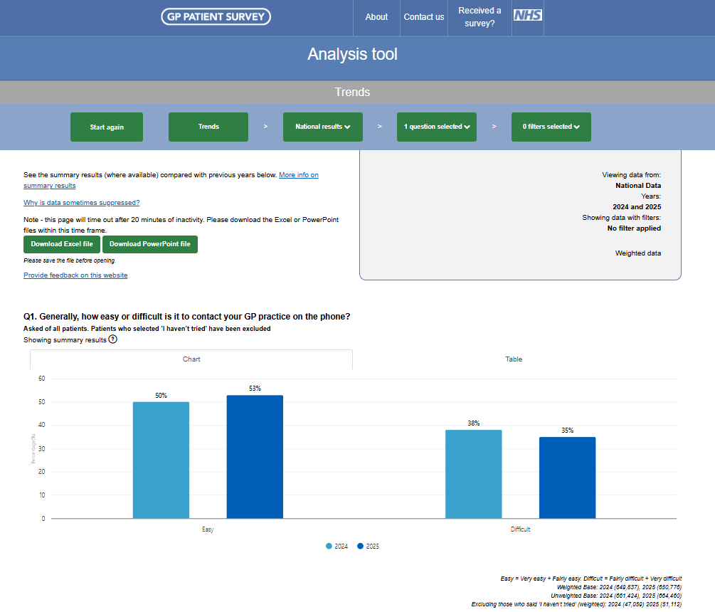
  - Practice comparison tool
Since June 2015, the main GPPS website also allows users to compare results across practices. This tool is available either through the practice search function on the home page or via the ‘Search for a practice’ and ‘Compare a practice’ links on the home page.
The practice comparison tool allows users to:
- view the results for a particular practice for a set of key questions and compare these results with the local ICS and national results.
- compare results with another local practice (within a 5-mile radius); and
- compare results with any other practice in the country.

Since July 2022, a practice summary PowerPoint download (‘Practice Infographic’) has been available with results for a particular practice for a key set of questions. Users can access this by searching for a practice, then clicking on the green ‘Practice Infographic (PowerPoint)’ button on the Practice overview and Area comparison tabs.

9
Data quality statement

- Data quality statement
  - Purpose
This data quality statement aims to provide users with an evidence-based assessment of the quality of the data used in the GP Patient Survey. It reports against the European Statistical System (ESS) quality dimensions and principles appropriate to this output.
In doing so, this meets NHSE England’s obligation to comply with the UK Statistics Authority (UKSA) Code of Practice for Official Statistics, particularly Principle Q3 which states that ‘Producers of statistics and data should explain clearly how they assure themselves that statistics and data are accurate, reliable, coherent and timely’.
  - Relevance
The degree to which a statistical product meets user needs in terms of content and coverage
The survey is designed in collaboration with a steering group consisting of members from national healthcare organisations, patient groups, charities, ICBs and GP practices, plus people with lived experience. The survey is regularly tested with a range of users, in particular when new questions are included.
The outputs are used by a wide range of users such as:
- NHS England and Department of Health and Social Care, to monitor the experience of patients and in policy development.
- ICBs, PCNs and GP practices, to understand aspects of patient experience in their area and how these have changed over time.
- Charities, to understand how experiences vary across different patient groups.
- Academic researchers, to inform research into aspects of primary care experience and how these vary across patient groups.
  - Accuracy and reliability
The difference between an estimated value and the true value
The figures in this publication come from a survey which gathers information from a sample rather than from the whole population. The sample is designed to be as accurate as possible given practical limitations such as time and cost constraints – see Chapter 3: Sampling for a description of how the sample is drawn, and Chapter 6: Data analysis on how this is accounted for in the presentation of the results. Results from surveys are always estimates, not precise figures. This can have an impact on how differences in the estimates should be interpreted.
As the number of people available in the sample gets smaller, the variability of the estimates that we can make from that sample size gets larger. Estimates for small groups are less reliable and tend to be more volatile than for larger aggregated groups.
To quantify the uncertainty around point estimates, 95% confidence intervals are presented in the outputs (see section 6.7 for more information).
Another aspect of accuracy comes from the quality of the data collected in the survey and subsequent quality assurance, which is described in general terms elsewhere in this document.
In particular we are reviewing the accuracy and reliability of two specific questions:
Which of the following best describes you?
- Male
- Female
- Non-binary
- Prefer to self-describe
- Prefer not to say
Is your gender identity the same as the sex you were registered at birth?
- Yes
- No
- Prefer not to say
These questions were introduced in 2021 after full testing and significant engagement. They were intended to be an inclusive way of capturing gender identity and a proxy for gender reassignment, while continuing to collect information on the protected characteristic of sex, since a combination of the two questions was designed to also be used to derive sex (see the survey FAQs on the website for more detail). However, there are indications that some responders are answering these questions in potentially unexpected ways, and we are carrying out an in-depth review before drawing conclusions and making future recommendations. In the meantime we have improved how we label these questions in the reporting outputs in order to improve accuracy and to help users interpret the data.

  - Timeliness and punctuality
Timeliness describes the time between the date of publication and the date to which the data refer. Punctuality describes the time between the actual publication and the planned publication of a statistic
The survey is collected and published annually. The publication contains responses that were received over a three-month period, with questions asking respondents to reflect on their experiences over a longer time frame. The complexities and cost of running an in-depth, representative, robust survey such as this mean that it is not currently possible to run the survey more frequently than once a year.
The publication is released several months after the survey closes to allow for data processing, analysis and quality assurance. In 2024, some outputs were staggered and released later; however this is not the case this year and it has been possible to release all outputs at the same time which will benefit users.
The release is in line with pre-announced publication dates.
  - Accessibility and clarity
Accessibility describes the ease with which users can access data. Clarity describes the quality and sufficiency of metadata, illustrations and accompanying advice
This publication is available in a bespoke website and is a combination of HTML web pages and Word and PowerPoint documents for description, charts, and graphs, with data provided in usable formats, such as Excel spreadsheets, csv files and web-based report building dashboard tools. The publication includes many of the Government Statistical Service recommendations on improving accessibility of spreadsheets for users.
The survey questionnaires and fieldwork communication materials are shared alongside the published results. This technical documentation describes the methodologies used to generate the survey sample and the subsequent results.
  - Coherence and comparability
Coherence is the degree to which data derived from different sources or methods, but that refers to the same topic, is similar. Comparability is the degree to which data can be compared over time and domain, for example, geographic level
The area of patient experience of GP practice is also explored in the ONS Health Insight Survey (HIS). This is conducted monthly and uses different methods and questions, therefore GPPS and HIS cannot be directly compared. Nevertheless there are some similarities in the questions that are asked, and statisticians and stakeholders from both surveys are in regular contact.

GPPS has been running for many years, however changes in questions asked, how the survey is administered and underlying methodology mean it is not possible to compare data across the full lifetime of the survey. Comparing across different domains is possible, taking into account the inherent uncertainty in the results and associated confidence intervals (see Accuracy and Reliability section).
  - Trade-offs between output quality components
The extent to which different aspects of quality are balanced against each other
Service delivery, national policy and survey administration methods can and do change over time and therefore it is necessary to revise both the questions and how the survey is delivered. However, changes of this nature are likely to break trends and therefore they must be balanced against user requirements for time series data. In practice this usually means large scale changes across different aspects of the survey are introduced in one go, and approximately every 5 years, in order to prevent more regular disruption to the time-series.
A survey of this scale and complexity requires a relatively long time period to administer, analyse and change, and this does come somewhat at the expense of timeliness. However, this is balanced against the depth and robustness of the resulting data.
Completion of the survey and all questions within it are voluntary and self-completed. Support is provided in a variety of ways to help respondents to complete as accurately as possible (see 4.2 Support for participants).

10
Appendix

- Appendix
  - Survey materials
The following survey materials are available on the website:
- 2025 questionnaire and additional online-only questions (note: questions 55 and 56 are currently under review by NHS England).
- Initial mailing letter.
- First reminder e-letter.
- Second reminder letter.
- SMS reminders.
  - Experiments
As part of the 2025 GPPS fieldwork, Ipsos and NHS England undertook a series of experiments to try to improve cost-effectiveness while maintaining response rates, as well as examining any changes in sample profile, survey estimates and costs, compared with the main survey design.
Experiments were carried out using a factorial design. Factorial design involves testing interventions in combination, rather than one at a time. Interventions can then be analysed by combining all groups involving that particular intervention. In addition, this has the advantage of allowing the impact of a combination of interventions to be analysed (e.g. potentially demonstrating that a positive impact on response rates from the introduction of a second e-letter instead of the final paper mailing and a separate positive impact from sending an email still applies when the two are combined).
This led to a series of experiments on a sub-sample of GPPS respondents, testing the impact of the following interventions:
- Replacing the final paper mailing with an e-letter: designed to reduce survey costs by decreasing the volume of printing and postage and encouraging more people to take part online.
- Removing the questionnaire from the final paper mailing: designed to reduce survey costs by decreasing the volume of printing and encouraging more people to take part online.
- Extra contact by email: providing an additional way of reminding people to take part, who may have otherwise waited until the next reminder (postal or SMS) or who may not have taken part at all.
- Contact by Rich Communication Service (RCS) message: RCS messages are an upgrade on traditional SMS and MMS, offering a more engaging messaging experience, including the ability to use branding, richer content and sender verification. RCS also offers features which may increase engagement and reduce costs, such as improved security and no character limits.
It was hoped that additional experiments could be run, including working with NHS Notify and using the NHS App. However, the legal direction for research had not been approved for Notify or the App by the time of fieldwork.
  - Allocation of sample to treatment groups
With the total sample of 2.72 million cases, roughly 54,500 cases were systematically selected to take part in the various experiments (using the method of random start and fixed interval). The sample was stratified by practice, with a ‘1 in n’ random selection. The 54,500 cases were randomly allocated to each of 11 treatment groups, with the rest of the sample receiving the ‘control’ approach.
  - Results
Analysis was carried out looking at the interventions across the different treatment groups (for example, looking at all the groups that had the e-letter) to look at the differences for each intervention compared with the groups that had not experienced that intervention (for example, looking at all the groups that did not have the e-letter). This concluded that:
- In the under 70s, replacing the final mailing with an e-letter or removing the paper questionnaire had a small negative impact on the response rate (1-2 percentage points). However, for those aged 70+, the negative impact was much more sizable (around 10 percentage points).
- Adding an additional email contact had a small positive impact on the response rate for groups that did not receive a paper questionnaire (1-3 percentage points). However, there was no noticeable impact on groups that received a paper questionnaire.
- RCS had minimal impact on the response rate (associated with an increase of about half a percentage point). However, this may have been impacted by the practical limitations of RCS for Apple handsets during fieldwork, which would need to be reviewed.
Further analysis is planned to assess the implications on cost, data quality, and non-response bias of implementing any of these changes. The non-response bias analysis will look at any differences in how respondents answer survey questions, as well as differences in demographic profiles of respondents and variation in response rates between demographic groups.

Analysis has already been carried out to look at the differences in results between the experiment groups and the main survey across a range of key survey estimates and demographic profiles. This found that there would be no impact on the results from including the experiment groups within the overall responses. Responses to the experiment interventions have therefore been included within published results for 2025; they equate to 1.9% of the total number of returned questionnaires.
Our standards and accreditations
Ipsos’s standards and accreditations provide our clients with the peace of mind that they can always depend on us to deliver reliable, sustainable findings. Moreover our focus on quality and continuous improvement means we have embedded a ‘right first time’ approach throughout our organisation.
ISO 20252
This is the international market research specific standard that supersedes
BS 7911/MRQSA and incorporates IQCS (Interviewer Quality Control Scheme). It covers the five stages of a Market Research project. Ipsos UK was the first company in the world to gain this accreditation.
Market Research Society (MRS) Company Partnership
By being an MRS Company Partner, Ipsos UK endorse and support the core MRS brand values of professionalism, research excellence and business effectiveness, and commit to comply with the MRS Code of Conduct throughout the organisation & we were the first company to sign our organisation up to the requirements and self-regulation of the MRS Code; more than 350 companies have followed our lead.
ISO 9001
International general company standard with a focus on continual improvement through quality management systems. In 1994 we became one of the early adopters of the ISO 9001 business standard.
ISO 27001
International standard for information security designed to ensure the selection of adequate and proportionate security controls. Ipsos UK was the first research company in the UK to be awarded this in August 2008.
 | The UK General Data Protection Regulation (GDPR)  and the UK Data Protection Act (DPA) 2018  Ipsos UK is required to comply with the UK GDPR and the UK DPA. It covers the processing of personal data and the protection of privacy.
 | HMG Cyber Essentials  This is a government-backed scheme and a key deliverable of the UK’s National Cyber Security Programme. Ipsos was assessment-validated for Cyber Essentials certification in 2016. Cyber Essentials defines a set of controls which, when properly implemented, provide organisations with basic protection from the most prevalent forms of threat coming from the internet.
 | Fair Data  Ipsos UK is signed up as a “Fair Data” company, agreeing to adhere to 10 core principles. The principles support and complement other standards such as ISOs, and the requirements of Data Protection legislation.

For more information
3 Thomas More Square
London
E1W 1YW
t: +44 (0)20 3059 5000
www.ipsos.com/en-uk
https://x.com/IpsosUK

About Ipsos Public Affairs
Ipsos Public Affairs works closely with national governments, local public services and the not-for-profit sector. Its c.200 research staff focus on public service and policy issues. Each has expertise in a particular part of the public sector, ensuring we have a detailed understanding of specific sectors and policy challenges. Combined with our methods and communications expertise, this helps ensure that our research makes a difference for decision makers and communities.

https://gss.civilservice.gov.uk/wp-content/uploads/2019/11/Guidance-on-Calculating-Compliance-Costs.pdf
Standard confidence interval testing uses the Wald method.
Power calculations apply a statistical test to protect against the risk of false negatives. False negatives occur when a difference that does exist is declared as not existing.
Please note that an asterisk (*) indicates a percentage of less than 0.5% but greater than 0.
Peter Lynn, Roeland Beerten, Johanna Laiho and Jean Martin (2001) Recommended Standard Final Outcome Categories and Standard Definitions of Response Rate for Social Surveys. ISER Working Papers Number 2001-23.
Prior to January 2016, reports are available for Regions and Area Teams; these are no longer provided following the integration of Area Teams into the four Regional Teams which existed at that time.

